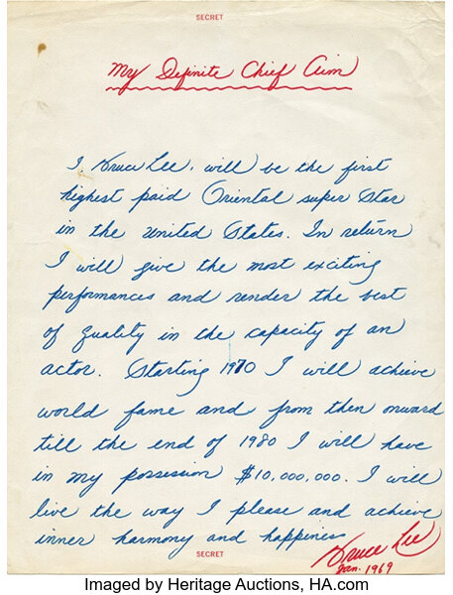

I, Bruce Lee, will be the first highest paid Oriental super star in the United States. In return I will give the most exciting performances and render the best of quality in the capacity of an actor. Starting 1970 I will achieve world fame and from then onward till the end of 1980 I will have in my possession $10,000,000. I will live the way I please and achieve inner harmony and happiness

