Operations & Fulfillment

The number one reason that “successful” agencies fail is that they eventually figure out their lead generation, but then they cannot balance consistent lead generation with also completing work at a high quality.

Most people, especially solo founders, never are able to do both of these things at the same time. They will generate enough leads to get it off the ground (usually to the $500k - $1 mil per year range), then they stop being consistent with lead gen to focus on operations and fulfillment, and then their lead generation dries up, and then some clients churn and then they have no more lead flow left and they are screwed.

This situation kills more “successful” agencies than anything else.

There is a very specific process that will get you past this whether you are a solo founder or have partners. It is the same process every time.

- List out every single task you do on a recurring basis
  - Lead generation
  - Operations
  - Employee training
- Assign a role, owner, frequency to each
- Add reminders to their calendar (or some other method)
- Add reminders to someone who verified that it is done
- Create an SOP for each task
- Create an overall deliverable checklist for each deliverable (all SOPs combined + simplified) that people can use
- Create/find nine examples of the finished deliverable done properly which will be used as a standard for your employees to compare their work against

Operations sheet

A spreadsheet is by far the best way to do this. It is far superior to all dumb apps in terms of ease of use, price (it’s free), and sharing between members of your company.

I do not like to use any tool such as Airtable or Notion or anything like that because they get so complicated that it defeats the purpose. This WILL happen, regardless of how cocky or confident you are as you are reading this in your current setup.

If you plan to scale, you will have 50, 75, or 100 employees/contractors at some point. Whether they are big or small, full time or part time, they will need to see this sheet too and you cannot afford to waste time, and more importantly, pay thousands of dollars per month for seats in a software that is inferior to a simple Google Sheet.

Your dashboard

This template will be in your Dashboard: https://docs.google.com/spreadsheets/d/1WzBD8jiug6Gb0rMN2z3xMYvJ8siAsTnQ-OTodyHMIPU/edit?gid=1677046994#gid=1677046994

Copy this and add it to your account.

Go to both the Operations Tab and the Checklists & Examples Tab. These are the two you will use for this system.

“Automatic” operations

Having a system like this is important because once you get past 10, 20, 30, 50, 100 employees, etc., it is no longer possible for you to help or even talk to all of them.

The DEFAULT needs to be to look at the sheet, not to ask for help. You need these complete step-by-step instructions and training for each task or you will be so swamped answering stupid questions that you won’t have any time to work on things that drive the business forward (including staying consistent with your lead gen).

This is exactly the situation that destroys so many agencies between $1 million and $3 million per year, and sometimes even at lower revenue levels depending on the pricing, business model and service delivery.

When you have something like this, your delivery will be “automatic.” However, you need to do every single thing that I tell you in this system, or that will not happen for you. Every piece is important. If you skip one step, it is your own fault when it doesn’t work as intended.

Step #1: List out every single task

The first step in this process is to layout every task you do on a *RECURRING* basis. This does not include one-time setups or anything like that. If you do not do it at least once per month, do not put it here.

Brainstorm all of them.

I typically will set it up into three categories:
- Lead generation
- Operations and fulfillment
- Employee hiring and training

There are times where I will add a fourth one for automations.

These are the three most important things to include as each of these categories is filled with tasks that you need to do daily, weekly and monthly.

It is also nice to break them up this way so you can find them more quickly than if they were all in one big block.

Do not underestimate this. There will likely be several dozen different tasks for each, and if there is not, you are most likely forgetting some. Take your time. A lot of these tasks will be dependent on previous tasks (eg. to upload a Facebook ad, you must first create the Facebook ad creative), and there are tons that waterfall onto others.

After you think you are done, you will want to send it to Matt for his review to see if you are missing anything.

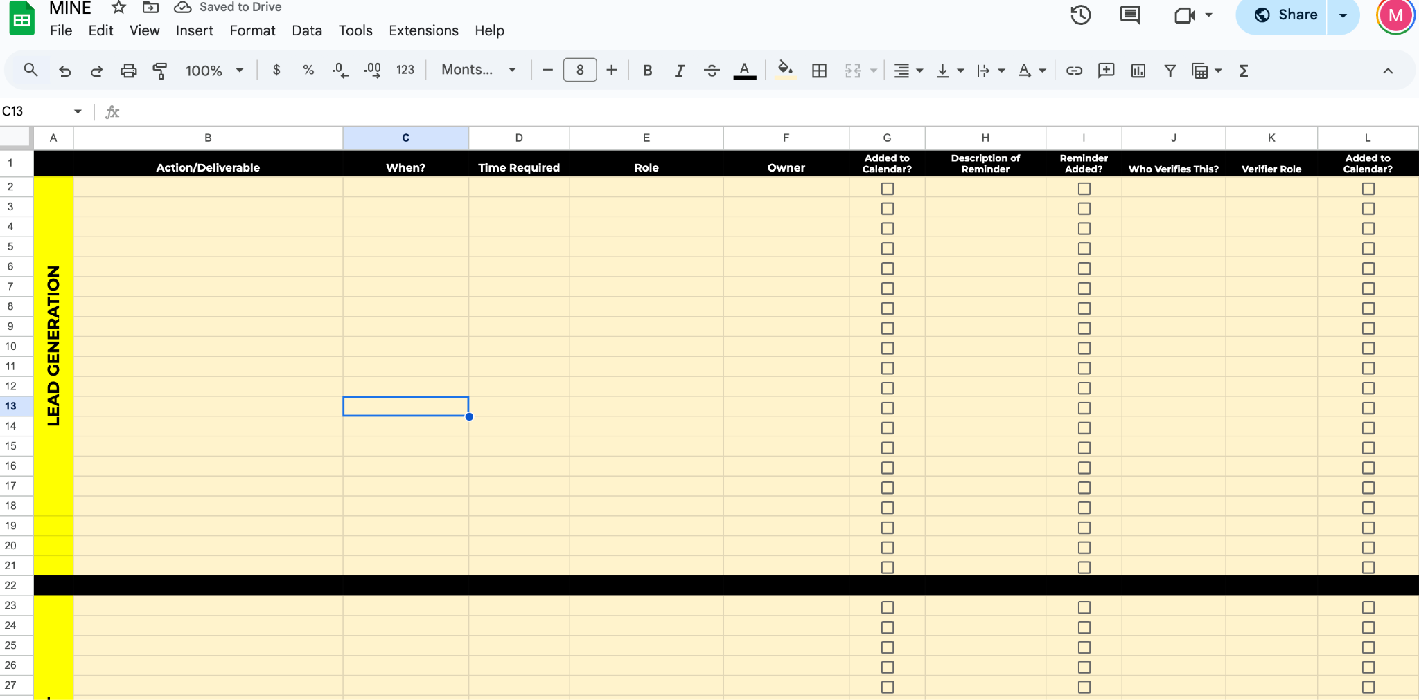

Step #2: Assign a role, owner & frequency

After you have all the tasks laid out, you need to assign some very important things:

- Role
- Owner
- Frequency/When To Do It

Think of the Role as the actual job title of the person. For example, you could say that this task should be done by the role of Account Manager and that will never change.

However, for Owner, think of it as the name/actual person. For example, you may have five Account Managers, but you want Jimmy to be the one (even though Jimmy is an account manager) to do this task.

Having a combination of Role AND Owner protects you against everything in your business. For example, if Jimmy left, you would still need an account manager to do this task and could assign it for someone else. But, if you just had Account Manager (with no Owner), then it would be confusing as to who is actually supposed to do this.

Then, you need to assign a frequency (if it needs to be done X, Y and Z times per week) as well as a “When.”

For example, creating three YouTube videos per week would be something like this:

Role: Founder
Owner: Matt
When: Monday, Wednesday, Friday

You will want to do this for every single task in your sheet. If certain tasks feed into each other, you should have the same person do all of them as part of the process.

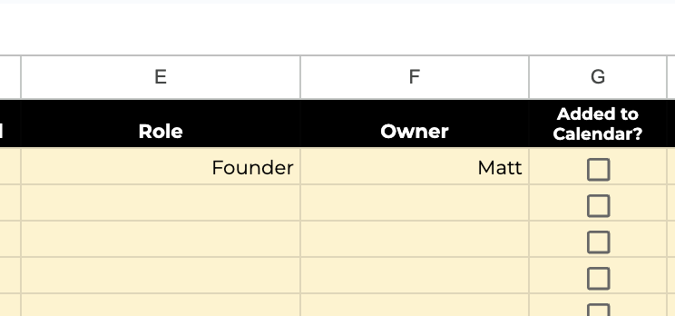

Step #3: Add reminders
It is VERY important to understand that none of this means shit if you don’t have REMINDERS that will automatically send to remind everybody to do their tasks.

People forget stuff all the time. It is your business. You can set up automatic reminders in Slack, Zapier, etc. to make sure they do these tasks.

Then, if they still don’t, they can be fired, as they are not doing their job.

I have found the best way to do this with Slack Workflows. This, of course, means you need to have Slack but there is no better and more cost effective way to do this.

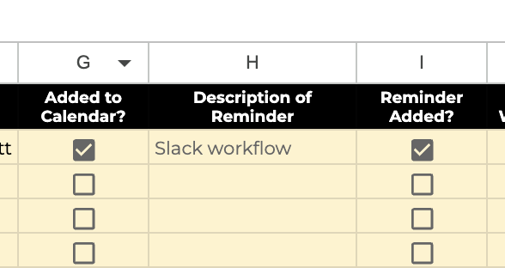

This takes a lot of time to set up, but will help you ensure your business actually operates properly and you are able to scale. It is quite simple to set up these reminders, but you just need to set up one for every set of tasks (which can take a long time).

The good news is that you only need to do this once, and it will serve you forever.

Step #1: Go here on your Slack and then choose Workflow Builder

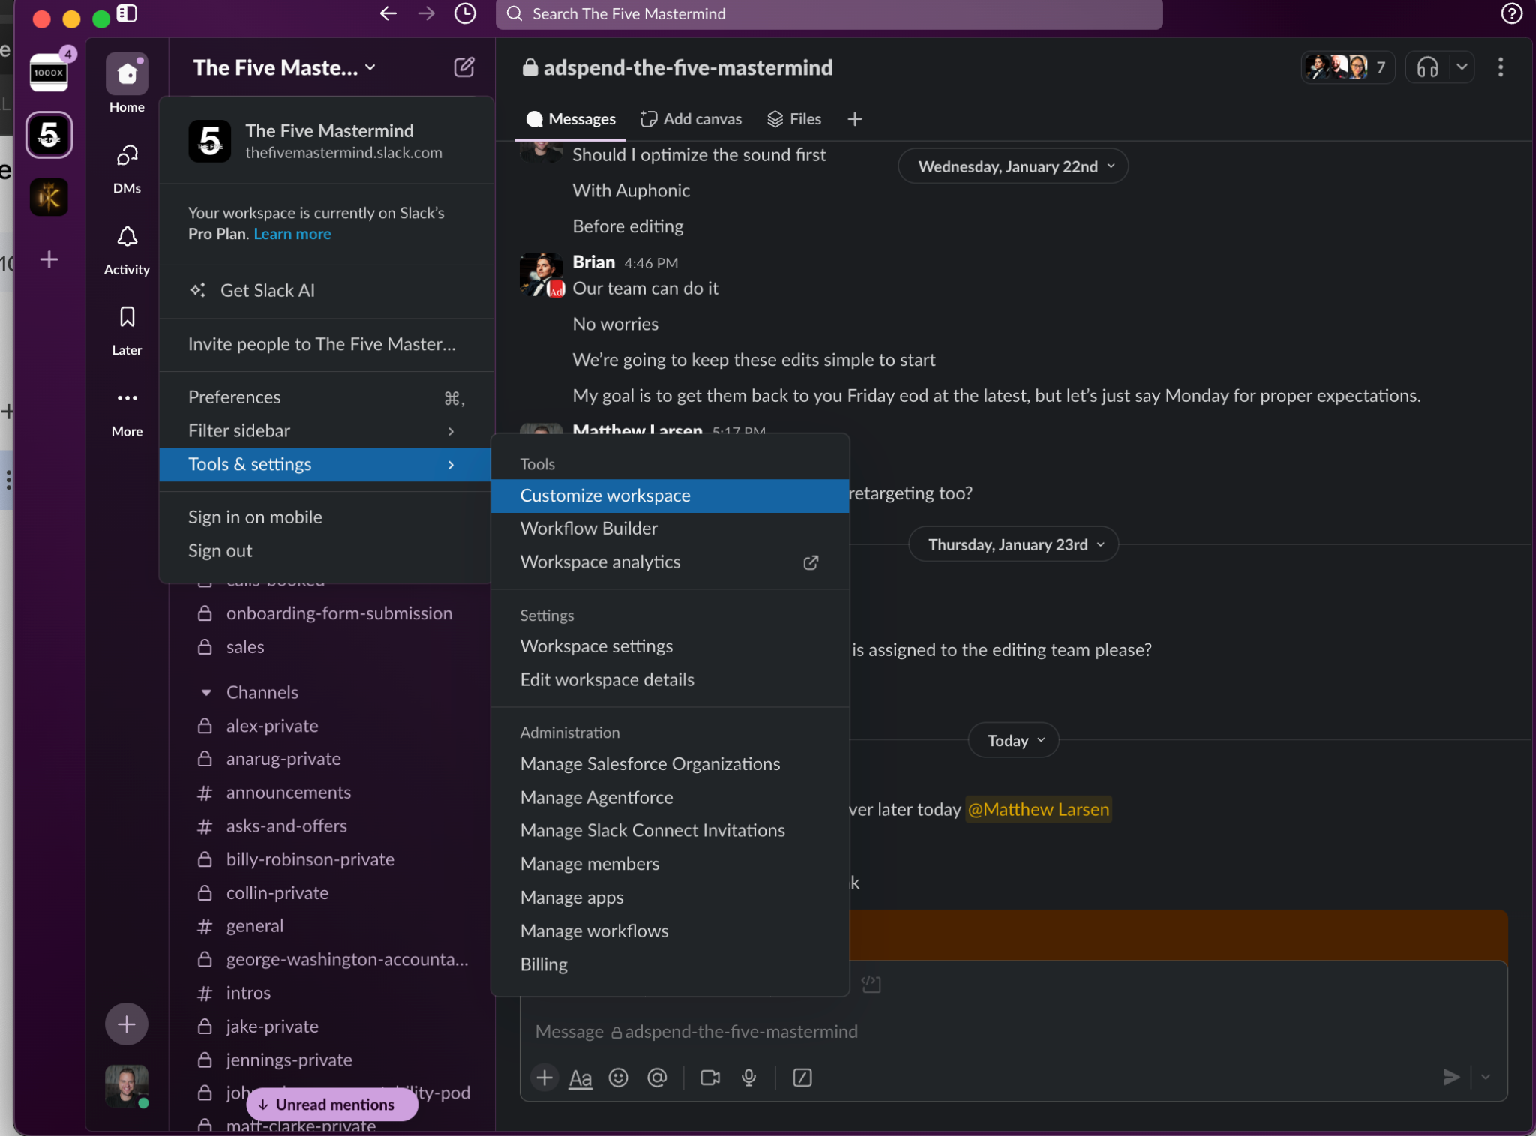

Step #2: Create a new workflow and set it to trigger on a schedule. This is the best option for 99.9% of reminders.

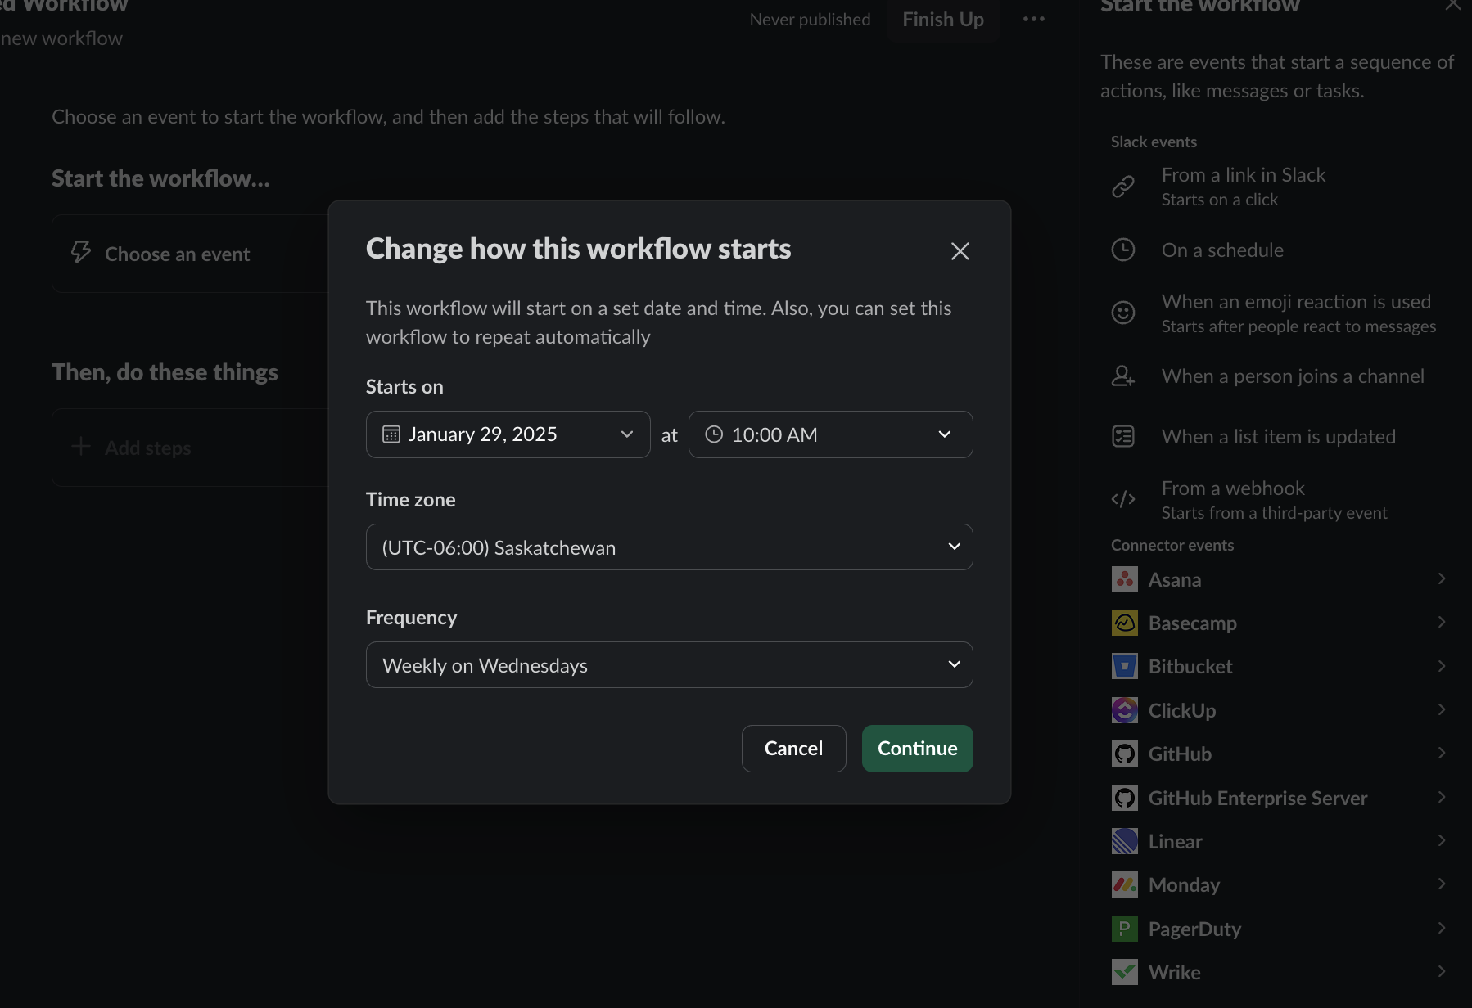

Step #3: Set it to send a message to either a person or a channel.

I always default to person here to keep it in line with the Owner in the system, but there are certain instances where the channel makes sense.

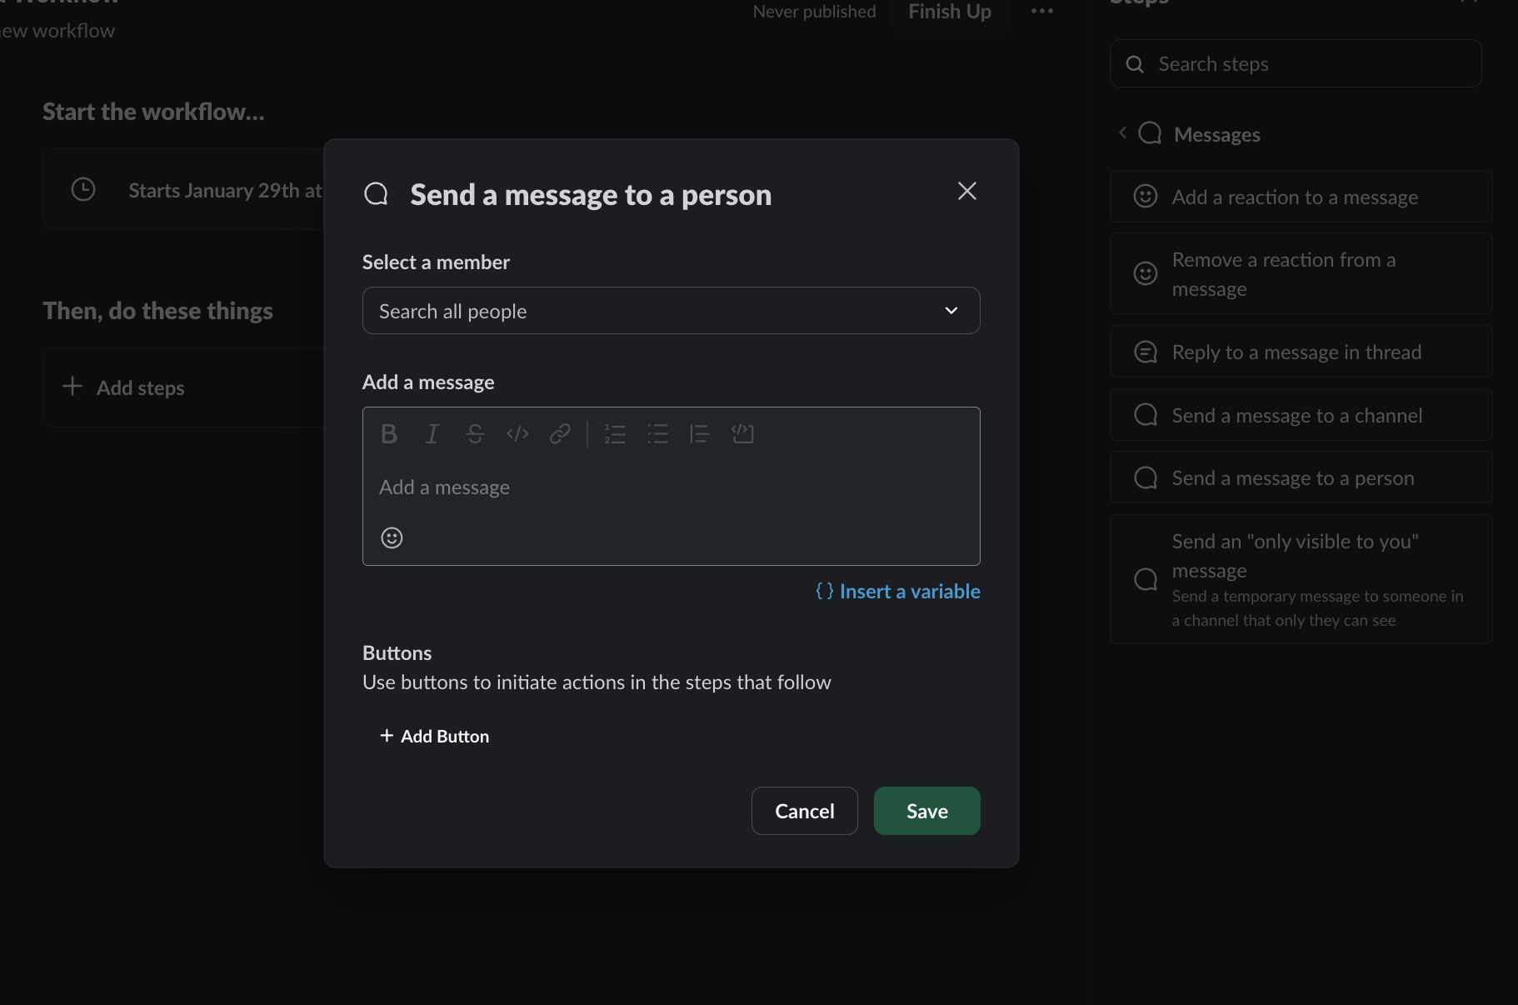

Step #4: Make sure you tag them, have the correct date, and then send them a message.

Make sure this message has a LINK to the operations spreadsheet and/or anything else they will need. Make it easy and as low friction as possible.

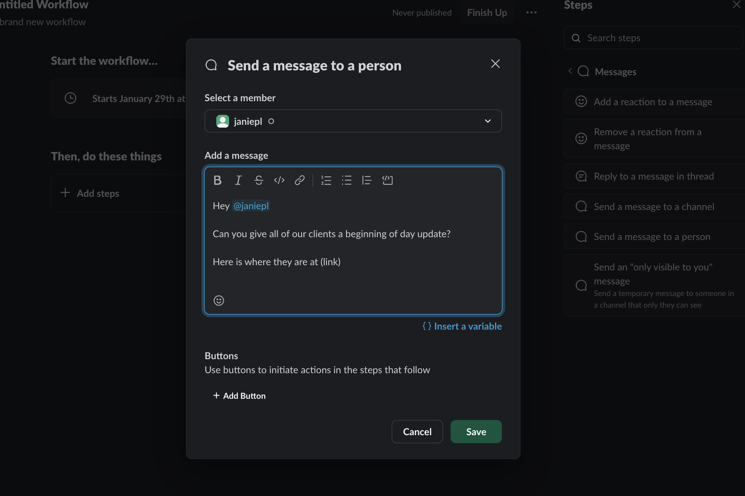

Step #5: Do this for every *set* of tasks.

If there are tasks that go together, you can send them the checklist link instead of the SOP or Operations link. But, you still need to have this set up.

This will take a couple days to set up for every single task, but you will save thousands of combined hours per year. It is a top 3 thing you could ever do in your business.

***IMPORTANT***: Make sure to stick to a naming convention.

You will always want to have a naming convention just in case someone quits, gets fired, etc. That makes it easy to replace them.

I always stick to this one:

(Role) - (Owner) - Task

This makes it easy to find and swap out if you need it.

There is an example below:

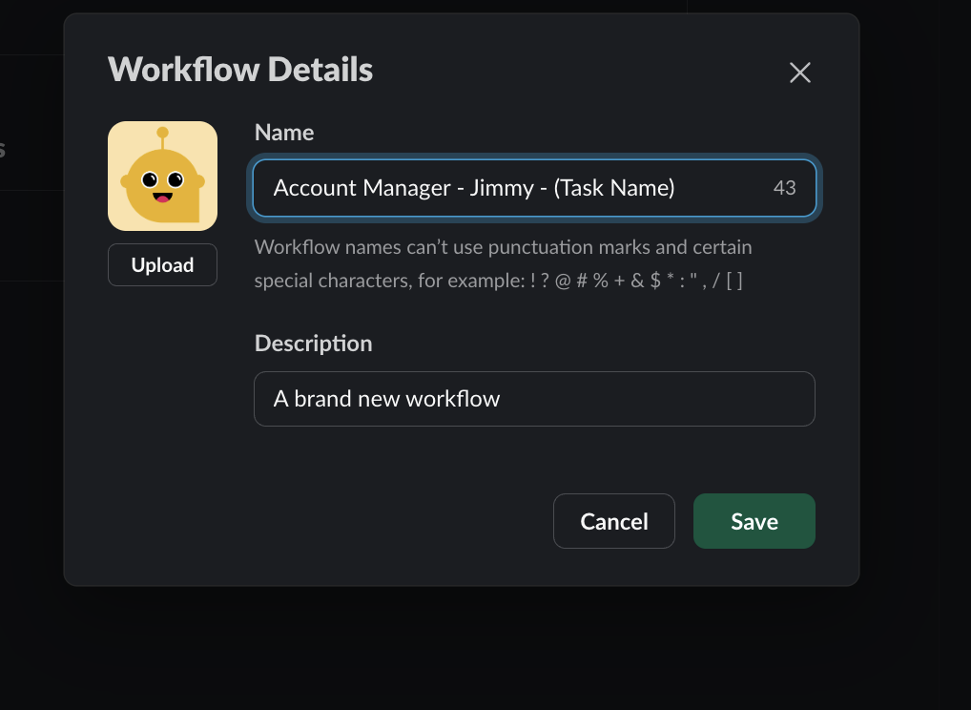

Step #4: Add verifier
It just keeps getting worse.

Again, none of this means ANYTHING at all (not the role, owner, reminder) if there is no one CHECKING and VERIFYING that it has been done.

In a similar fashion to good old Stalin saying “it doesn’t matter who votes, it matters who counts the votes.

Just like you have to have a reminder to do the task, you need a reminder for someone else to verify the task is done.

This reminder will usually go to project managers, accounts managers and those type of people. They will be the ones responsible for verifying and if stuff doesn’t get done, it is the fault of them and the person combined.

This is how you build “top down” operations. Every step in the chain of command is responsible and blaming others will not be tolerated.

You will want to set up a Slack Workflow to remind higher up people to check and verify the work, and you will make it part of the employees end of day forms to upload all their links/work they did to make it easy for the higher up people to check.

- Reminder to do the task (previous step)
- Reminder to manager to check the task
- Make uploading links/work part of the End of Day form (This is inside the Employee Management System) https://docs.google.com/document/d/1k1TrVQN-VeFgwZPJxVxMRkxiD68W26Xl4ar9Tzc88pU/edit?usp=sharing)

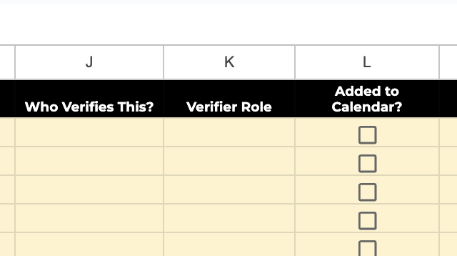

Step #5: Create SOPs
The next thing to be done is to fill out a list of SOPs. SOP stands for standard operating procedure.

There are two parts that need to happen here:

- Every time you do something, you should be recording a Loom of you doing it, and that Loom should be added to the spreadsheet.
- When you have your Loom, you should get the transcription, and ask ChatGPT to turn it into a detailed, step-by-step SOP.

This will take no additional time and should be done as part of your normal every day work. Having this video and this transcript is very important though. It will be a great troubleshooting step for people who are truly stuck.

In many cases, some would consider an SOP and the checklist we are going to go over in step #6 to be the “same thing” but I do not agree whatsoever.

The main difference is that this SOP is a mindless step-by-step of how to do it in a literal sense. The following checklist will be a training and “skill transfer” checklist used to replicate yourself in your business. You will also likely have many different SOPs, with one per task. The checklists are kind of like an overall SOP that covers the entire deliverable.

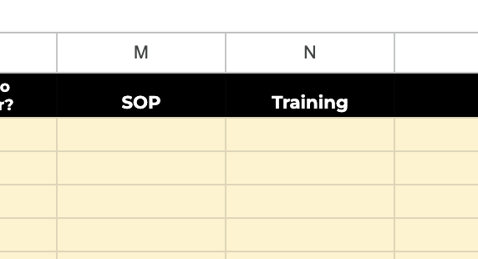

Step #6: Create checklists
This checklist will be one of your most important “skill transfer” tools.

You will make a checklist to do X deliverable. This will be a 100% step by step checklist from start to finish, not leaving out a single step.

YOU SHOULD BE ABLE TO CORRECTLY FULFILL THE DELIVERABLE WITH JUST THIS CHECKLIST AND NOTHING ELSE.

This checklist is your most important training tool. Here is what you will do:

- Get on a Zoom call with a new employee.
- Do the task in front of them WITH ONLY the checklist. If you need something besides this, the checklist is not correct/complete
- Then, after you do it in front of them, switch.
- They do the deliverable in front of you WITH ONLY the checklist. If they cannot, you need to fix the checklist. If you fix it three times and they still can’t, fire them.
- Once they successfully do it in front of you, they are now FULLY trained on that skill. This process can turn 6 months of training into an hour or less. I have seen it hundreds of times. You have now COMPLETELY transferred your skill to them.

You will have one of these checklists for every key deliverable. There could be one. There could be 20. However many there are, that is how many checklists you will need.

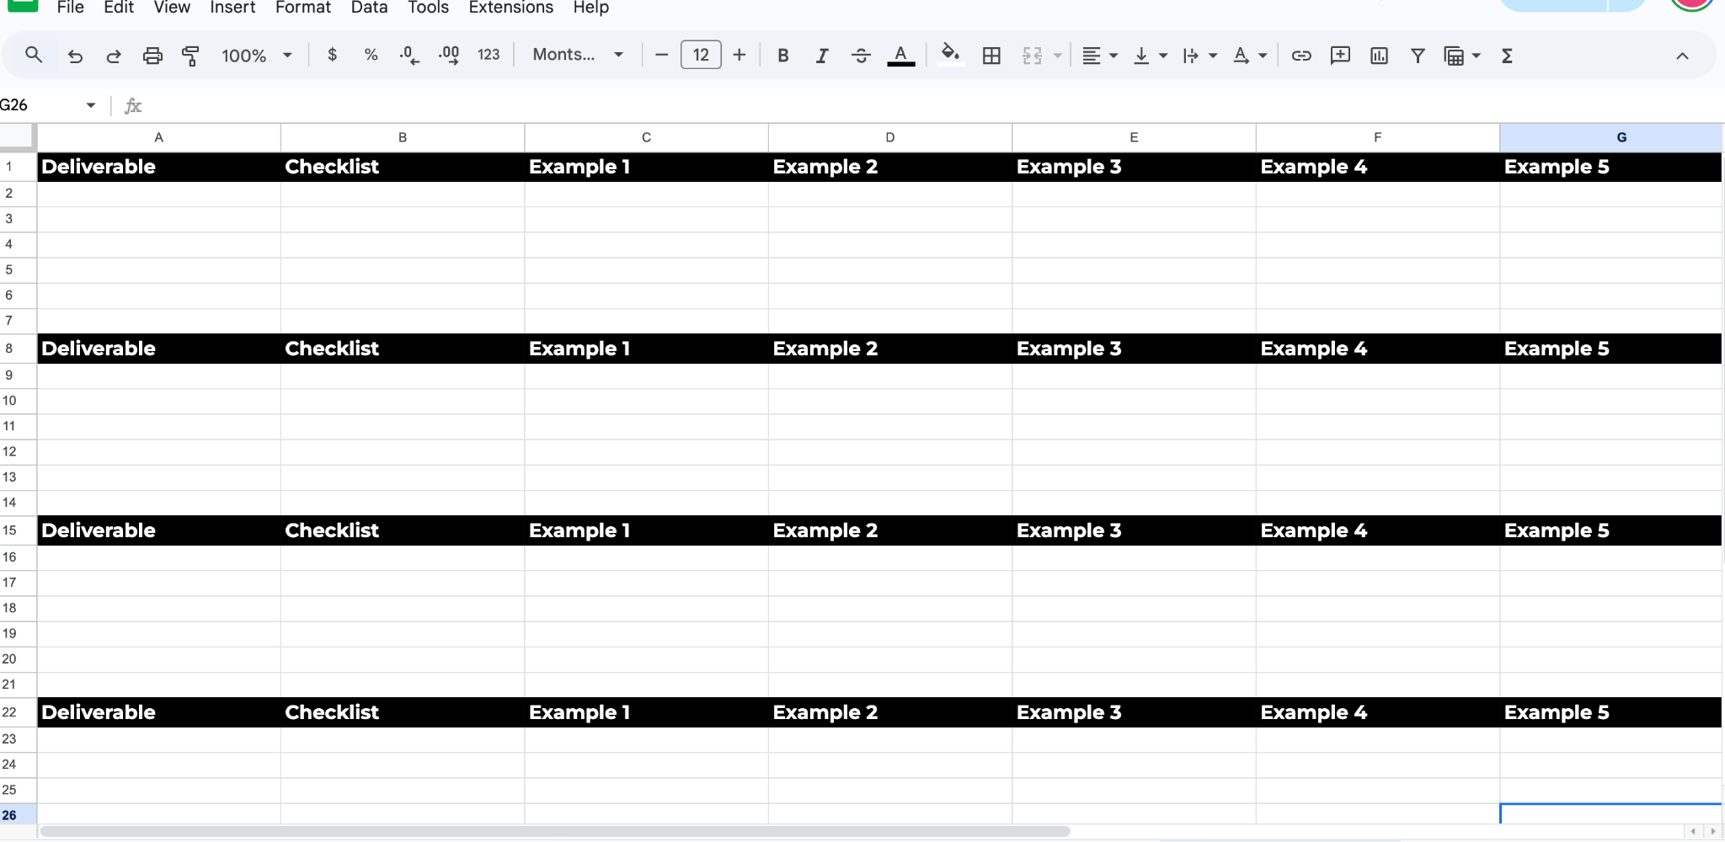

Step #7: Gather examples
The final step goes hand-in-hand with the checklists.

You will need examples for every deliverable. In fact, you will want to have about 9 different examples to give a good mix.

This will:

- Show your employees what standards you have
- GIve them something to compare theirs to
- Show them what it should look like if they get stuck
- Provide inspiration for them if their mind is blank.

With nine deliverables, you have a good enough mix to help your employees in almost every situation.

These examples can be visual, video, written, or in any other format. You should always prioritize visual examples when possible.

These examples will solve four of the biggest problems/most common questions you have, 100% automatically (ie) Is this good? Do you have an example? I am stuck. I can’t think of anything)

