Sales System

Prelude

A lot of people will look at something like this and think they do not need it. Sure, when you are a founder doing under $300k per month and you do all the sales and you know your stuff inside and out, you may not need it. Does that make you feel good?

But, if you ever expect to grow your business to any serious level of revenue, you will need sales reps, and they are not you. What works for your sales reps WILL work for you. However, what works for you USUALLY will NOT work for your sales reps.

They do not have years of experience. They need a process that they can be plugged into and see good results relatively fast or they are going to leave and/or they will blow all of your calls.

So, before you think you are some sort of sales god, look at it through that point of view, and do exactly what I say in this process. This is about making it EASY to sell. Not getting “better” at sales. That is a key distinction. When you do this right, you won’t need hardcore sales training because you have set them up to succeed. It will be MUCH easier than the average sales job they have had in the past.

Our goal is to create a *process* (not a script) that we can plug people into and get them good results within a 14 day period of starting.

The Three Most Important Qualities In Sales

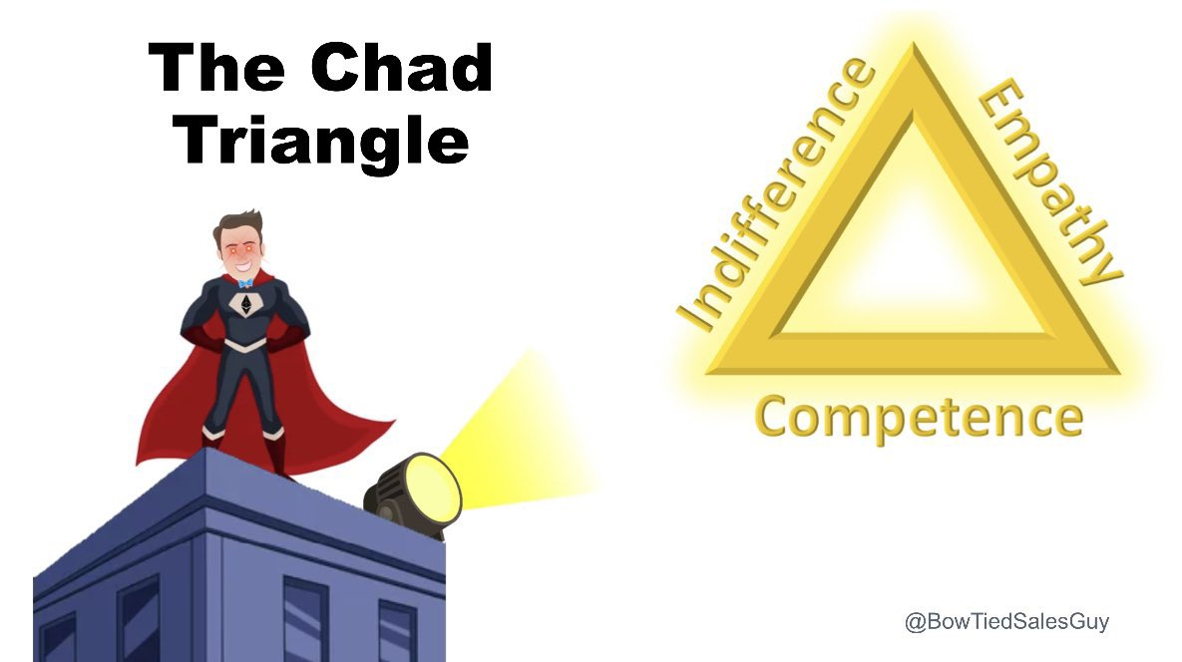

There is this sales trainer who I really like on Twitter named BowTiedSalesGuy. He is mostly for Enterprise B2B SaaS sales type stuff so it is not overly relevant, but I love his “triangle of sales.”

The three most important quality of a great salesperson are:

- Empathy
- Competence
- Indifference

1. Empathy

Why it matters: You have to actually understand what your prospects care about. People want to feel like you get them, not like you’re just trying to shove a product down their throat.

What it looks like: Ask real questions, listen to their problems, and show them you’re on their side. If they feel heard, they’ll trust you.

2. Competence

Why it matters: If you don’t know your product or service like the back of your hand, why would anyone trust you to sell it? Competence equals confidence.

What it looks like: You handle objections easily, explain the value in a way that makes sense to them, and come across as the expert. If you don’t believe in what you’re selling or can’t explain it clearly, you’re dead in the water.

3. Indifference

Why it matters: People hate desperation. If you’re chasing them too hard, you lose all your leverage. The second you’re indifferent, you flip the script—they start chasing you.

What it looks like: You stay calm, collected, and detached from the outcome. If they don’t see the value, that’s fine—someone else will. No begging, no convincing, just straight confidence.

How It All Comes Together

- Empathy gets them to trust you.
- Competence proves you know what you’re doing.
- Indifference makes you the prize, not the other way around.

(All of these things can be practiced and trained)

Congruence

If you show me a non-congruent sales funnel on one of our one-on-one calls, my god. I will kill you.

Here is the definition of congruence:

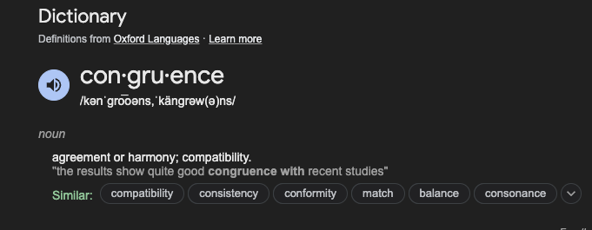

This is THE MOST important part of the sales process. Here is what it should look like in practice:

- Message in the ad should match what the headline is on the VSL landing page
- The first few lines of the VSL should match the headline on the landing page
- Once they get on the call, it should match what you talked about in the VSL
- Once they get sold, the onboarding should be matching what you said on the sales call.

And so on.

Everything MUST be congruent.

Phase 0A: Pre-Framing

Much of the success of a sales call will come before the sales call even takes place.

This will be heavily done by our other systems such as:

- Pre-Call Flow System
- Retargeting Ads System
- YouTube Videos System
- Posting & Cross Posting System

If these other systems are done correctly, they will already be warmed up and pre-framed for our call.

They will be:

  - More likely to show
  - More likely to know what you are talking about
  - They know the price ahead of time

Especially when we are selling to ad and cold email traffic, these four systems will make a night and day difference.

This whole system is about making it easy for our sales preps, so it is important we take all of those seriously as well.

Phase 0B: Pre-Call Calendar Questions

You should be asking qualifying questions in your Calendly or on a Typeform (which precedes your Calendly).

You should be asking the following questions at a minimum:

- What is your name?
- What is your business email?
- What is your phone number?
- What is your website?
- What is your revenue?
- Our (offer) costs X (or between X and Y). Are you okay with that?
- Where did you learn about us? (eg. YouTube, newsletter, Twitter, etc.)
- How long have you known about us? (eg. 1 hour, three months, a year, etc.)

These questions, especially 6-8 are really, really, REALLY good as they will arm your sales reps with some essentials.

- They will know the price ahead of time
- They will know where they came from (Example: “oh, you watch Matt’s YouTube videos?”)
- They will know how long they have known about you (They will be able to gauge how warm or cold this lead is, and it is also good for you to gauge sales cycles)

This is setting your sales reps up for success and these questions are seamless on a form and people will have no problem answering them.

Phase 0C: Pre-Call Research

Here’s a thought: Make your sales reps actually take 10-15 minutes before a call, and you know, prepare. It is so good that the average normie would call this a “life hack.” In reality, it is just basic common sense. If you are prepared, you will naturally be more confident and if you are more confident, you will close more sales.

They will be armed with information from Calendly questions such as their website, revenue level, where did they come from and how long have they known about you which is a good start, but they still need to do manual research.

They should have a document or piece of paper with the following:

1. Answers From Calendar Questions
- Name, business email, phone number, and website.
- Revenue (helps determine business size and budget).
- Confirmation they’re okay with your pricing range.
- How they found you (platform or referral source).
- How long they’ve known about you.

2. Company Overview
- What the company does (brief description).
- Who their target audience or customers are.
- Key metrics (revenue, customer base, etc.).

3. Team Members
- Who booked the call (name, title, and decision-making role).
- Other stakeholders who may influence the decision.
- Organizational structure (team size or relevant departments).

4. Offer Positioning
- How your offer solves their specific problem.
- What makes your offer unique or better than alternatives.
- How your offer aligns with their goals.

5. Social Proof
- Relevant case studies from similar clients.
- Testimonials or feedback from past clients.
- Results or recognitions that build credibility.

Phase 1: Introducing Yourself

One thing that will hold your reps back a ton is they simply do not have the level of credibility or authority that you do. There is nothing that can be done to change that. It is what it is.

Because of this, they need to compensate by making a great first impression that puts them in the driver seat and instantly captures the frame of the call.

Important: The person who is asking the questions is the one in control.

You need to give them something they can say every time that achieves this goal. The easiest thing to get them to say is below:

Intro Script:

“Hey, my name is X and I am from Y company. I have a background in ABC which is specific to (the problem you solve).

I work closely with (the person who is the face of the brand) and I would love to know what resonated the most with you.

The purpose of this call is to see if you qualify for our (offer). Not everyone does and it is really based on these X factors.

“

What People Usually Do:

“Hey, my name is X. Where are you calling from? Oh, nice. I know we have limited time so let’s get started.”

Dumb.

Transition To Phase 2:

It will be very easy to say something like “mind if I ask you a few questions to see how you compare to our most successful clients?”

They will say yes, and then you can move onto Phase 2.

Phase 2: The Five Questions

After the intro, our sales reps will have the “upper hand” in this call and the prospect will be trying to justify why we should take them instead of the other way around.

This is what we want.

Next, we need to build on this momentum and advantage and we will do so by asking you five specific questions. These questions are meaningful and move the call forward instead of “sideways” like most stupid questions that people ask.

These questions are:

- Why are we here today?
- Why are you interested in solving for X?
- Why is that a problem?
- Why is now the right time?
- Why not (alternatives)?

These are the five magic questions. Asking these questions is a natural follow up from the intro line of the call, and will feel seamless for your rep to transition to.

I am going to go through them one at a time.

(Before I get started explaining each, use your brain please. You do not need to ask these questions precisely how they are worded. Any variation will work. Thanks).

Example

I am going to do my best to illustrate what this may look like in the real world.

I am going to do it from the perspective of you selling paid ads to B2B companies.

Why are we here today?

This question is very similar to our first question we asked during the intro (I work closely with (the person who is the face of the brand) and I would love to know what resonated the most with you).

In about 80% of cases, they will just tell you why they are here today and what the problem is and you can take them at face value. For the other 20%, you can poke and prod a little until you get the truth.

The key thing to remember is that this person is interested. They booked a call and they already know the price from the calendar form. They wouldn’t be here if they weren’t interested. This is an important thing to keep in mind and internalize for your reps.

If you feel that answer was satisfactory, then you can skip this question. If you feel their answer wasn’t good enough, then you may ask this question again (or some variation of this).

A big theme of these five questions is that not only do they give you good information to use throughout the rest of the call, the big benefit is that you are getting them to say it out loud and admit it to *themselves*.

That is even better than admitting it to you. When they verbally admit it out loud, they cannot deny it later during the “close” of the call. Even if these answers are obvious and/or you had this information from the calendar call form before, you need to get these questions again.

Example 1:
“We’re here because our lead flow has dried up, and we need a better way to bring in consistent opportunities.”

Example 2:
“We’re looking for a more scalable solution—what we’ve been doing just isn’t cutting it anymore.”

Example 3:
“Our ad spend isn’t translating into actual ROI, and we need to figure out why.”

Why are you interested in solving for X?

After you learn of the problem they are trying to solve, you now need to know why they want to solve this problem.

Again, this is good information for you to use later, but it is very important for them to admit it to themselves out loud.

The answers you get here will vary greatly and that is why I refer to this entire thing as a *process* and NOT a script. You cannot account for every single possibility in a script and it becomes painfully obvious when a sales rep is reading from one and trying to stick to it.

Example 1:
“We want to unlock the full potential of our sales team and make sure they have high-quality leads to close.”

Example 2:
“We’ve got aggressive growth goals this year, and solving this gets us closer to hitting them.”

Example 3:

“We know there’s a huge market out there, and we don’t want to miss the opportunity to capture it.”

Why is that a problem?

The next thing after you know what the problem is and why they want to solve it, you need to backpedal a little bit and find out why they want to solve this problem.

There is a very subtle and nuanced difference between this and the previous question.

A beautiful way to think of this question vs. the previous one is that the previous questions were based around their motivations for solving this problem. This one is more based around the consequences of not solving that problem.

Again, the main focus here is getting them to admit these things out loud. You gathering information is almost a secondary benefit.

By asking this question after the previous one, you will usually get a better answer. The previous question leads much of the time to the answer that sounds good. This one leads more to the real answer.

Example 1:

“If we don’t figure this out, we’re going to keep missing revenue targets, and that’s going to hurt us long term.”

Example 2:
“Our competitors are gaining traction, and we’re losing ground while we’re stuck with inefficient strategies.”

Example 3:
“If we can’t fix this, it’s going to burn out our sales team, and we risk losing good people.”

Why is now the right time?

Again, we are staying in line with them admitting to themselves, but this is good information for us.

Timing is everything in sales. You cannot “create” urgency for this type of sales (like you can with an Ecommerce product discount/sale, or price increase for something). You can only discover if it exists or not.

An idea/quote that I really like is that “the goal of marketing and sales is to stay top of mind so that when someone is ready to buy, they immediately think of us.”

This question is very good because it will determine how hard to push them. If now is not the perfect time, you may ease up on them a bit so you stay in their good graces so they think of you when the time is perfect.

If now is the perfect time, then it is CLOSER time.

Example 1:

“We just raised a funding round, so now is the time to invest in growth before the market gets more competitive.”

Example 2:

“Our board wants results this quarter, so we don’t have the luxury of waiting any longer.”

Example 3:

“We’re launching a new product soon, and if we don’t figure this out, the launch won’t hit the numbers we’re expecting.”

Why not (alternatives)?

The final question is very important and will act as a perfect transition to the next phase of the call to make it easy on your sales reps.

We need to find out why they don’t like other solutions (why not cold email or content instead of paid ads)?

We need to find out what they don’t like about other companies/offers so if we have something similar in our offer, we do not bring it up or talk about it (why not hire X agency or join Y program instead of us?

We need to find out the consequences of doing nothing (why not just do it yourself?)

Our sales rep has to use their best judgment here as you typically would not want to bring up all three versions. You would only ask/bring up the version that they have brought up in the previous questions or on their own.

Example 1:

“We’ve tried doing this in-house, but we don’t have the expertise to get the results we need.”

Example 2:

“Cold outreach hasn’t worked—it’s too slow, and the response rates are terrible.”

Example 3:

“We’ve looked at other agencies, but they don’t seem to actually deliver on their promises.”

Transition To Phase 3:

It is very easy for your sales rep to say something like “Okay, it sounds like you are quite similar to our most successful clients, mind if I show you a few slides with our offer?”

They will say yes, and then you can move on to Phase 3.

Phase 3: The Presentation

This phase is all about having an asset that you can screen share and do a small presentation. This should last between 5-7 minutes, so we have time for objections and the close.

There are two things we want to think about here:

- Preventing objections
- Overcoming objections

We all know how to overcome objections, but preventing them is easier for the same reason it is easier to prevent diabetes (diet, exercise, sleep) than it is to treat it/live with it.
This presentation should follow a certain path, and should be thought of as one big “FAQ destroyer” that incorporates proof that this actually works.

Here are the phases of a good sales presentation:

- A 60 second highlight reel showing off right at the start
- What you do
- How you do it
- Why you do it
- Examples
- Offer
- Price/Cost
- FAQs

This is all you need. It should be done in 7-12 minutes. Do NOT overcomplicate it.

Transition To Phase 4:

The absolute easiest transition here is to say something like “so, on a scale of 1-10, how likely are you to buy this right now?”

They will give you a number and this number will usually be honest.

Then, the next phase has begun.

Phase 4: Objection Handling (You Will Constantly Bounce Back & Forth Between This & Closing)

No matter what you do, there will always be some objections and you should have a cheatsheet ready to handle each and every one of them.

Once they tell you their number, the first thing you will want to ask them is “why not a 1/10” or you can ask “what do you like about it?”

They will tell you.

Then, you should say “what would need to happen to get it from a 7 (example) to a 10?”

Then, here comes the objections, so be prepared.

Common Objection Cheat Sheet:

- Can you do this for less?
  - “I could do it for more”

- The other guy is cheaper
  - “Why didn’t you go to the other guy then?
  - “Because you have XYZ”
  - “Exactly, we are better so it costs more”

- It’s not about the money
  - “Let me ask you a question, if it was free, would you do it?”
  - “Yes, if it was free.”
  - “Exactly, so it’s not about the money.”

- “I am (insert emotion eg. nervous)
  - If you weren’t, I’d be worried about you, because this is a serious commitment, so the fact that you are nervous makes you exactly like everyone else who succeeds, like it’s a lot of money. I’d be surprised if you didn’t say that, but you know what you have in common with some of our best clients? They said the same thing, right before they signed up.”

- “I don’t have X” (such as I don’t have the money or I need to talk to my spouse)
  - “I think the reason that you need to do this is because you don’t have money. I think this is the perfect reason to take the leap and learn what you need to know. What you are currently doing has led you to the exact situation you are in right now.”
  - “I think the fact that you need to talk to your spouse about a financial decision like this is probably the reason you should do it, because wouldn't you want to have a business that has enough cash flow that this isn’t a major decision?”

Important: If you do not know how to answer their question, ask a question about their question.

Phase 5: Closing (You Will Constantly Bounce Back & Forth Between This & Appointment Setting)

The people who close the most deals are the ones who ask for the sale the most times. But, you cannot do this over and over in the wrong way without pissing people off.

Most alphabet formulas are stupid and make you sound like a weird robot (very off putting), but there is a good one closing, or more specifically, asking for the sale more times without making the person hate you.

This is the AAA formula:

(A)cknowledge
(A)ssociate
(A)sk

Acknowledge:

Action: Repeat back what they say

Example: I totally understand, you want to think about it a little bit.

Associate:

Example: Some of our most successful clients said the same thing

Ask:

Example: Let me ask you about that, what is your main concern?

Then, make the next move in the conversation and keep asking for the sales in different ways.

Once They Say Yes & They Are Going To Do It:

You need to tell them the EXACT next steps.

Phase 6: Follow Up

Regardless of what those dumbass, generic sales trainers lead you to believe, most people do not “pay in full right on the call” the majority of the time. They may indeed have to talk to their wives or business partners because we live in reality, not some make-believe world that the sales trainers live in.

If people pay on the call or right after, great!

However, for the vast majority, we will need to follow up, and we will need to follow up often.

Within 5 Minutes (Next Steps)

Right Away: Send them an email with the contract, payment link and next steps. This should be done as soon as possible after the call. If you do a two-call close and this is the first call, just send the next steps.

Days 1-3: First Impressions (Big Wins)

Day 1: Drop your best case study.
Example: "How [Client X] doubled their revenue in 3 months with [Your Service]."

Day 2: Share your top client transformation story.
Example: "From [struggle] to [success]: How we helped [Client Y] turn it around."

Day 3: Hit them with your biggest industry insight.
Example: "The #1 trend no one in [your niche] is talking about (and how you can capitalize on it)."

Days 4-10: Objection Killers (Reverse FAQ)

Day 5: Handle Objection #1: The most common concern.
Example: “Will this even work for my business size?” Show proof it will.

Day 7: Handle Objection #2: Cost.
Example: “Here’s why this is worth the investment (ROI breakdown included).”

Day 9: Handle Objection #3: Trust.
Example: “Why the people who’ve worked with us stay with us.”

Days 11-40: Consistent Value (2 Emails/Week)

Week 3 (Days 11-17):

Day 13: Success Story.
Example: “How [Client Z] pulled off [specific result] faster than expected.”

Day 15: Industry Insight.
Example: “3 trends in [your industry] you’re probably sleeping on.”

Week 4 (Days 18-24):

Day 20: Success Story.
Example: “How [Client A] turned [specific challenge] into [specific win].”

Day 22: Industry Insight.
Example: “Why most businesses in [your niche] fail—and how to avoid it.”

Week 5 (Days 25-31):

Day 27: Success Story.
Example: “The unexpected strategy that got [Client B] ridiculous results.”

Day 29: Industry Insight.
Example: “The biggest mistake people in [your niche] are making right now.”

Week 6 (Days 32-38):

Day 34: Success Story.
Example: “How we helped [Client C] increase [specific metric] by [percentage].”

Day 36: Industry Insight.
Example: “How the [industry landscape] is changing—and what you need to do about it.”

Week 7 (Days 39-40):

Day 39: Success Story.
Example: “Why [Client D] says working with us was the best move they ever made.”

Day 40: Final Industry Insight.
Example: “What’s next for [your industry]—and how to stay ahead of the curve.”

The Key (DO NOT IGNORE)

Every Email Stands Alone: Each one should hit so hard they feel like they’re getting free value even if they never buy.

Soft CTA: End with something light like, "Want to talk more? Just hit reply."

