YouTube

This is very much a plan to get you going with YouTube. It will serve you well at the start, and get you to 10,000 subscribers.

YouTube is very important both for Top of Funnel traffic but also for converting people who already know about you.

You should think of YouTube as purely a tool to teach. You don’t have to be loud or cringe or like an influencer. Just teach concepts that have to do with your service. Low pressure, low stress.

Once you are over 10,000 subscribers, you will get into the details. Until then, just aim to make it AS EASY AS POSSIBLE to make videos.

100 shit videos is far better than no videos at all.

You should optimize for total watch time. This means making long videos thoroughly explaining XYZ to your target market. When you do this, they become more comfortable with you. It’s like “spending time” with you.

This is very high leverage because you can make a one hour video and then it could get thousands of hours of watch time. 1 hour in, thousands out. Time multiplication.

- Equipment
- Finding Outlier Titles + Thumbnails
- Turning Into Your Own
- Intro
- Scripting Formula
- Body Points
- Optimizing Audio
- Uploading

Home Studio Options

If you are at home more than 300 days per year, go with this setup.

Sony ZVE10 Camera - $698

Sony 16mm Lens - $399

Elgato Prompter - $279 (important that you get this one specifically as it is the only one that you can use your computer to change what’s on the screen. The others you have to upload to your phone and it is a super hassle.

Neweer Continuous Light - $199

Neweer Softbox - $84

Neweer Light Stand - $69

Small Rig Tripod - $120

Dummy Battery - $22 (this will make it so you don’t have charge/mess with any batteries

Shure MV7 Mic - $279 (make sure you get one that has USB too in the title. This one does. If you get an XLR one, you will need extra equipment)

Mic Stand - $39

Travel Studio Options

If you are at home less than 300 days per year, go with this setup. It will fit in a checked bag for airplanes and won’t take up much space in a car.

Because travelling and desks at hotels/AirBnBs are so reliable, we don’t want anything that needs to clamp on to anything.

Sony ZVE10 Camera - $698

Sony 16mm Lens - $399

Elgato Prompter - $279 (important that you get this one specifically as it is the only one that you can use your computer to change what’s on the screen. The others you have to upload to your phone and it is a super hassle.

Small Rig Tripod - $120

Dummy Battery - $22 (this will make it so you don’t have charge/mess with any batteries)

Shure MV7 Mic With Stand - $299 (doesn’t require a clamp)

Desktop Lights (2 Pack) - $89 (doesn’t require a clamp)

Step #1: Finding Outlier Titles

The entire strategy starts at finding titles and video formats that have already worked for people in your niche.

This saves a lot of time on thinking of ideas, creating thumbnail concepts, and so on, while also making it more likely that you will get more views.

I will be putting these ideas in your dashboards, but if you want to it on your own, the best way to do so is with a cheap software called https://1of10.com

This lets you sort YouTube videos by multipliers.

For example, if you set the multipliers by 3.5x or above, it will only show videos from that creator that got 3.5x as many views as their average video at the time. We can consider these videos “outliers” and when you start to do this, you will begin to see a lot of patterns.

Here is an example of Alex Hormozi’s videos that are all a multiplier of 3.5x or more.

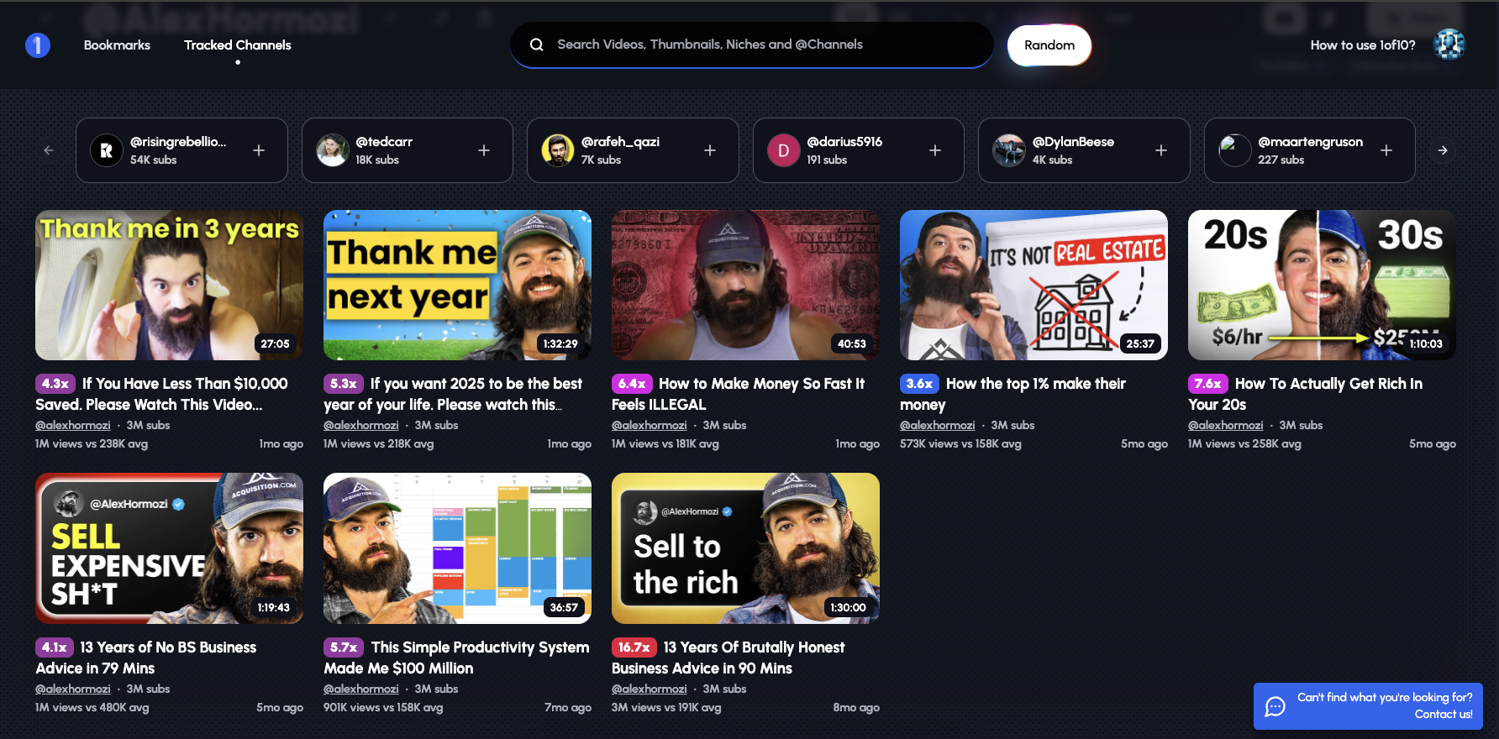

When using this tool, use the following criteria:

- Try to find people in your niche first. If you can’t/once you need more, go broader
- For small channels, do a 5x+ multiplier. For big channels, do a 2x+ or more.
- Only allow videos in the past 12 months to make sure they are currently relevant
- Gather ideas and titles from at least 10 channels, then put them into ChatGPT and ask for the repeating words/themes/formats.
- Tailor at least 25 of these video titles and concepts to your own niche. For example, I made a video called “How To Grow Your Agency So Fast It Feels Illegal” based on one of those outliers.
- Go to your OWN DUPLICATED dashboard and put these all in the YouTube tab https://docs.google.com/spreadsheets/d/1WzBD8jiug6Gb0rMN2z3xMYvJ8siAsTnQ-OTodyHMIPU/edit?gid=1418457134#gid=1418457134. I will be putting ideas in there as well.

Step #2: Get The Title + Thumbnail First

It is very important to create the title and thumbnail before making the rest of the video. This is because the video needs to match and be congruent with the title and thumbnail.

When you do this backwards, it is very difficult to try and make a title and thumbnail fit a video.

What I always recommend is to get about 30-40 photos of yourself (shoulders and above) and then get someone on fiverr to optimize and edit these photos and take the background out.

Then, you can just have a bunch of photos of yourself and text. This is all you really need when getting started with YouTube. Once you hit 10,000+ subscribers, you can hire someone. At this point, we want to create a good system for ourselves to get as many YouTube videos out as quickly as possible.

Here is a thumbnail template as an example:

https://www.canva.com/design/DAGcwJ4jL6M/u9-rHCHUFSFveomIv1r9IQ/edit?utm_content=DAGcwJ4jL6M&utm_campaign=designshare&utm_medium=link2&utm_source=sharebutton

Step #3: Create An Asset To Screenshare & Talk Over

The next step is very important.

Set a timer, and spend ONE hour creating either slides, a document or a Miro Board.

This is the asset that you will use to teach. This replaces your script and helps you stay on track, without having to read verbatim off a script. This sounds way more natural and is better received in terms of B2B videos.

Do not spend more than one hour creating at this point. It is best to create assets that you would want to create anyways for your operations, fulfillment, and clients. This kills two birds with one stone.

Give away the secrets, and then they will come to you for implementation.

Step #4: Script The Intro

The intro is the only part of the video that I think you should script. It will be 30 seconds or less then you can edit it onto the rest in CapCut after.

The reason for this is that the intro plays an outsized role in how much watch time you will get. If they click on a video and the intro is unrelated, sounds stupid, or is boring, they will just click away.

There are three things that your intro should accomplish:

- Raise curiosity
- Make it clear you’re credible to build trust
- Make it clear it’s not clickbait

Before we get started, we should ask ourselves the following question:
What three questions will viewers want to know the answer to when they see your title and thumbnail?

This is good information to include in your intro as it “confirms” the title and thumbnail and gives them the content that they were probably thinking about anyways.

- Writing The Hook
  - Short as possible
  - Focus on creating curiosity
  - Make it relatable to the packaging or viewers big problem
  - Try to keep it under five seconds
    - Question hook
    - Fact hook
    - Strong statement hook
    - Credibility hook

- Transition
  - Poke the problem
  - Teasing the result
  - Poke problem + tease result

- Setup
  - Get people excited about what’s coming
  - Build curiosity
  - Let them know about the value of the video
    - “So in this video, I’m going to show you X, Y, Z from #1”

- Transition To Point #1
  - Let the viewer know why they should care about the first point
  - “To start…”

(Weave credibility statement in here)

Example

Intro
Transition

What separates your channel from the people in your niche who have no real experience in your topic and just make videos repeating what they heard online?
If you can't answer that instantly, it means you’re making one of the biggest mistakes on YouTube.
So today I'm going to show you 5 critical things businesses owners must say or do in every video, so that viewers instantly want to listen to them more than anyone else in their niche.
These 5 things have helped me generate hundreds of millions of views and tens of millions of dollars for my clients.

So what is this big mistake I'd say 99% of businesses make on YouTube?

(Goes to the screenshare asset and rest of video)

Step #5: Film The Intro

Load this up into your Elgato Telerompter, stare at the camera, and say it.

I recommend you do not consider using an intro that you haven’t even filmed 10x.

You should be filming this 10x. Every time you repeat it, you become 2x more smooth, natural, and compelling.

VOLUME is important. Do this. It is a super hack.

Step #6: Film The Rest Of The Video

Film the rest of the video talking through your screenshare asset. Try to be as relaxed as possible. A conversational tone is the goal. This will take time.

If you made your asset correctly, there should be relatively low pressure to talk through this.

A key thing is to pretend you are just talking to one person. An interesting thing for me is 4 of my top 5 videos were filmed in front of a live audience (webinar). I talk so much differently when I am recording, so you may want to talk to someone on Zoom (or just have someone over there) while you are recording.

You will probably still be horrible at this either way. Get to 100 videos as fast as possible and don’t worry about it so much.

Step #7: Edit Together

It is very easy to just edit these together in CapCut. It takes 5 seconds at most. You do not need to pay someone. Do not do any other editing other than editing these together.

Step #8: Go Through Auphonic

This is a sound engineering app that will make your videos sound so much better and it will automatically upload to YouTube for you if you follow this workflow.

- Sign up for Auphonic at https://auphonic.com
- Sign up for Dropbox at https://dropbox.com
- Connect YouTube channel to Auphonic in Services Tab
- Connect Dropbox to Auphonic in Services Tab
- Connect Auphonic and Dropbox so you get an Auphonic folder in your downloads

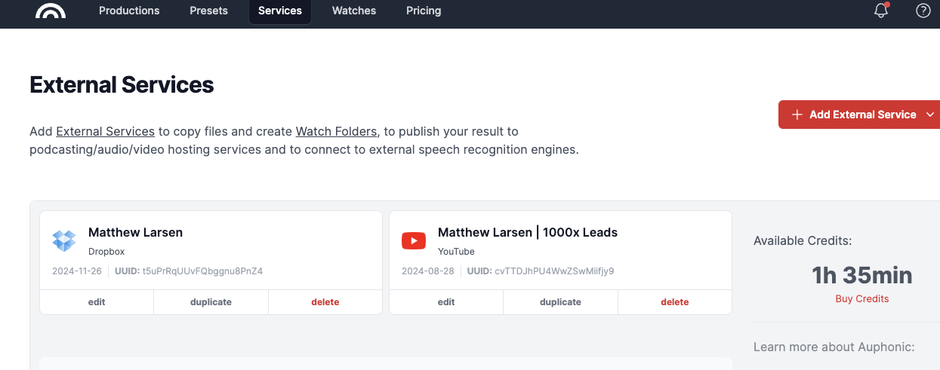

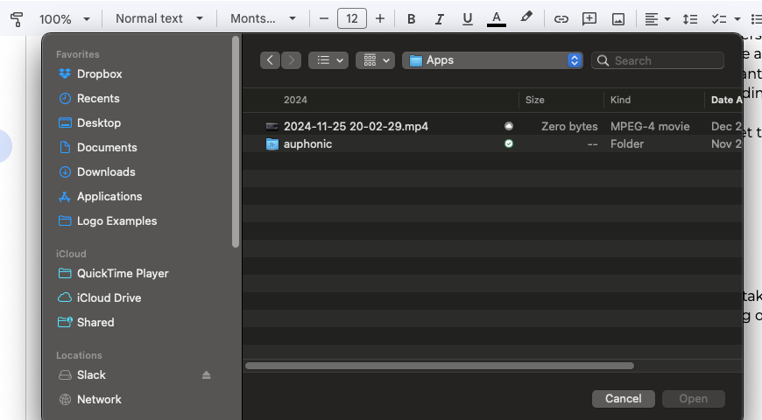

- Change your CapCut settings to export to the dropbox/auphonic folder in downloads.

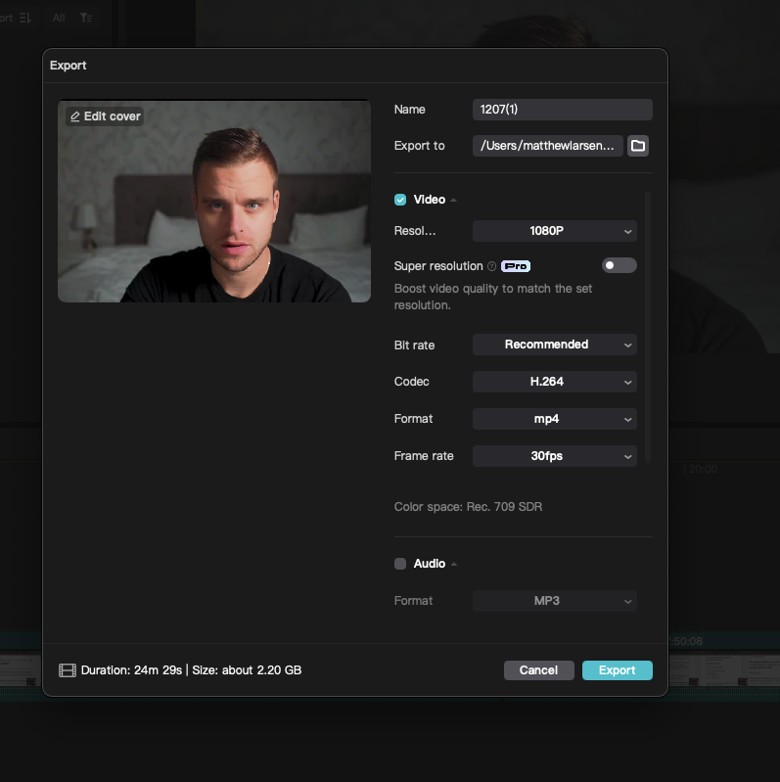

- Set up a Preset in Auphonic

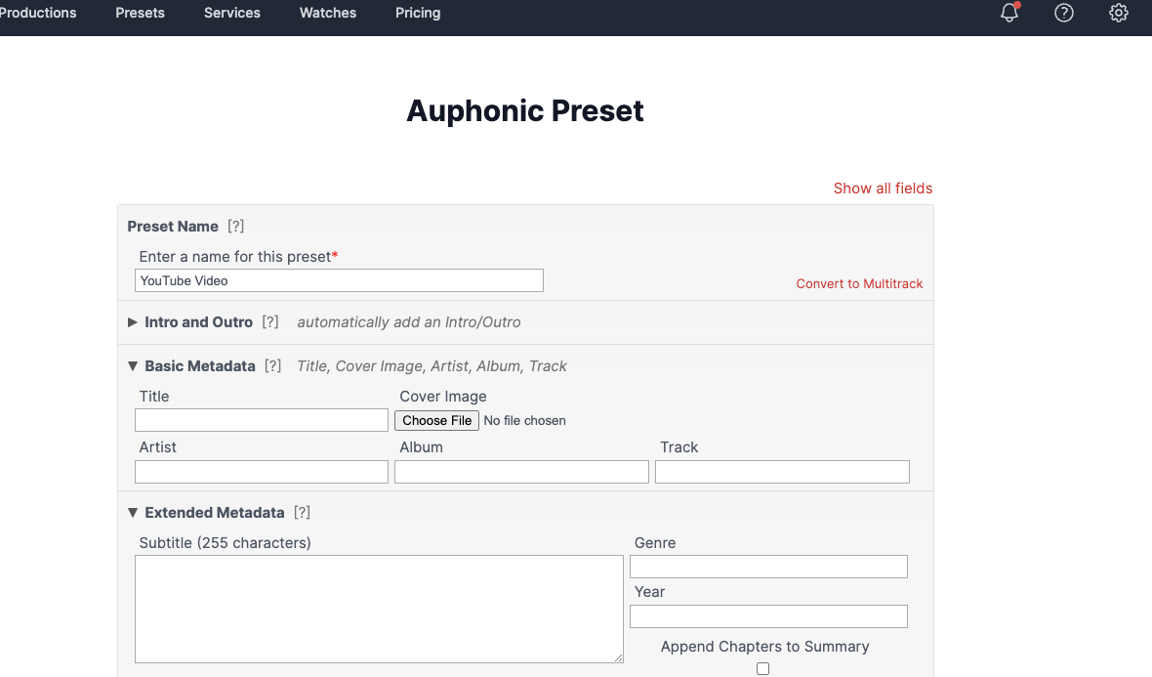

- Copy the settings in the picture below

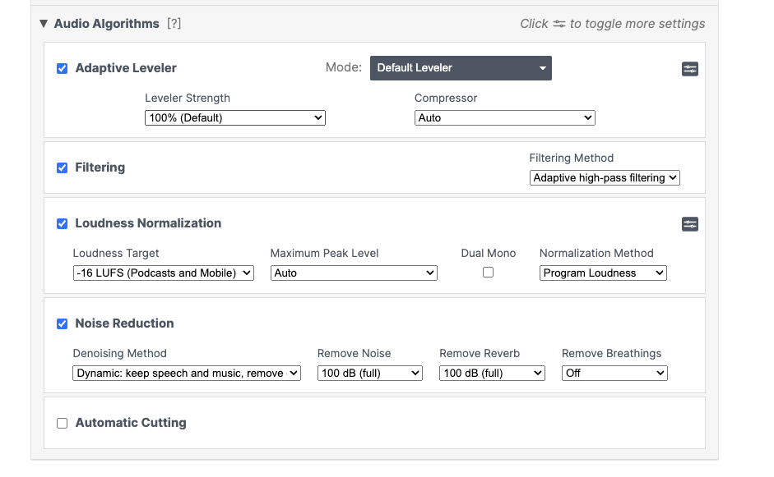

- When you export from CapCut, this process will begin automatically with this setup. The sound will be optimized and it will be automatically uploaded to YouTube where you can add the title, thumbnail and schedule it.

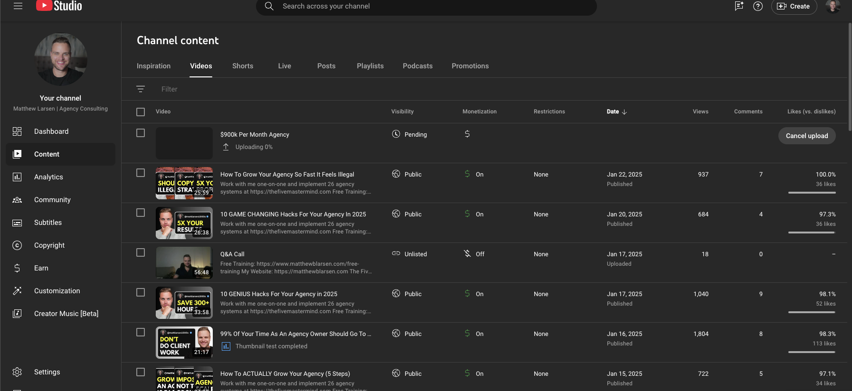

Step #9: Lead Magnet In First Line of Description + Pinned Comment

Make sure the very first line of your description, as well as your pinned comment has the link to your lead magnet. We want to get them on our list so we can nurture them.

This is far superior to book a call or any hard selling if your ticket price is over $10k LTV.

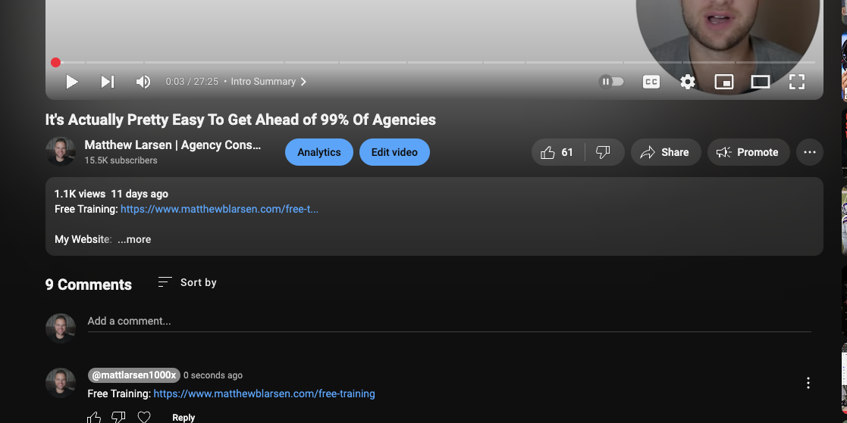

Step #10: Schedule When Subscribers Are Active

Look at this section in your channel analytics and see when your subscribers are most active. Schedule it at that time.

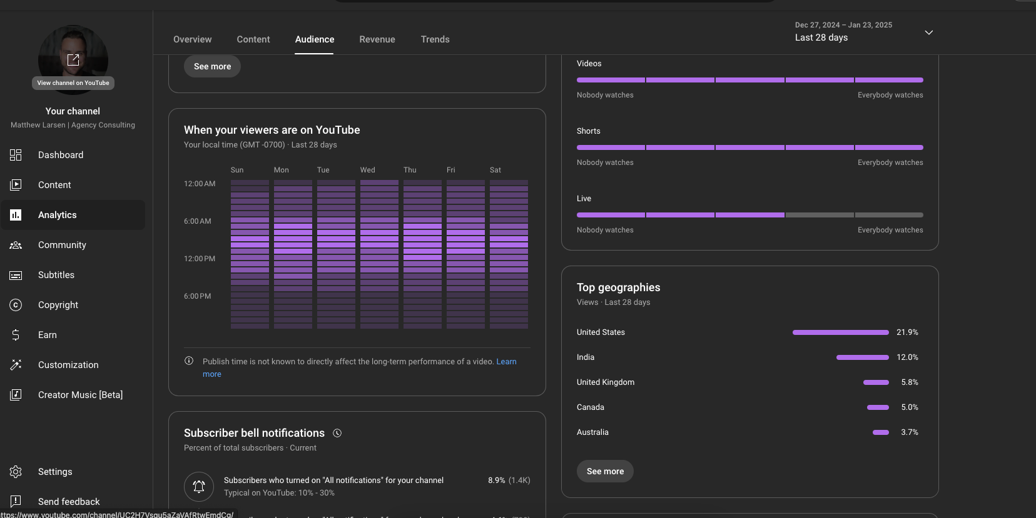

*IMPORTANT* Step #11: Watch Your Own Video Every Day

The number one thing you can do to improve is to watch your own videos every day and then critique yourself.

There is nothing that will accelerate your progress more than doing this. You can either watch, or you can listen to it while you are doing things like working out or on the treadmill.

This, and I am not joking, will accelerate everything by a factor of 10-50x. You will notice how you speak, look, content, etc. in a way that you never would otherwise.

It is essential to self-criticize in this way.

*IMPORTANT* Step #12: List Three Things To Improve For Next Video

You will quickly make a huge laundry list (unfortunately) of things you can improve. Aim to improve three things in every video. If you use this system and get in a good rhythm, you will be posting 3-7x per week.

The amount of progress you can make with three improvements per day is insane. Your improvements will stack on each other and you will get compounding returns.

*IMPORTANT* Step #13: Keep A Quality Assurance Checklist

As you make these improvements and “level up” your videos, you need to keep some sort of list or checklist to make sure you do all the things you improved every time.

If you do the improvements and then stop, it is like you didn’t do any improvements at all. Every time you make an improvement, that becomes the new standard that you abide by for your videos.

