🎉 Leave a 5-Star Review – Get an Extra 10% OFF (Stackable)! 🎉

Have you purchased a course from us before? Now’s your chance to unlock even more discounts — just by leaving a quick review!
👉 For every 5-star review you post on Trustpilot, you’ll get an extra 10% OFF bonus — and yes, they’re stackable with our current discounts:
✨ Pay via PayPal or Credit Card:
10% OFF + 10% Review Bonus = 20% OFF total
✨ Pay via Crypto:
20% OFF + 10% Review Bonus = 30% OFF total
💥 Leave multiple 5-star reviews (for different courses you’ve bought), and you’ll get multiple 10% OFF bonuses that can be used on future purchases!

✅ How to claim your discount:
- Leave a 5-star review here: https://www.trustpilot.com/review/course24h.com
- Take a screenshot of your review(s)
- Send it to: amandabynes@course24h.com
- Include the course(s) you want to purchase
→ We’ll reply with your exclusive discounted payment link
📚 Full course list: https://course24h.com/courselist

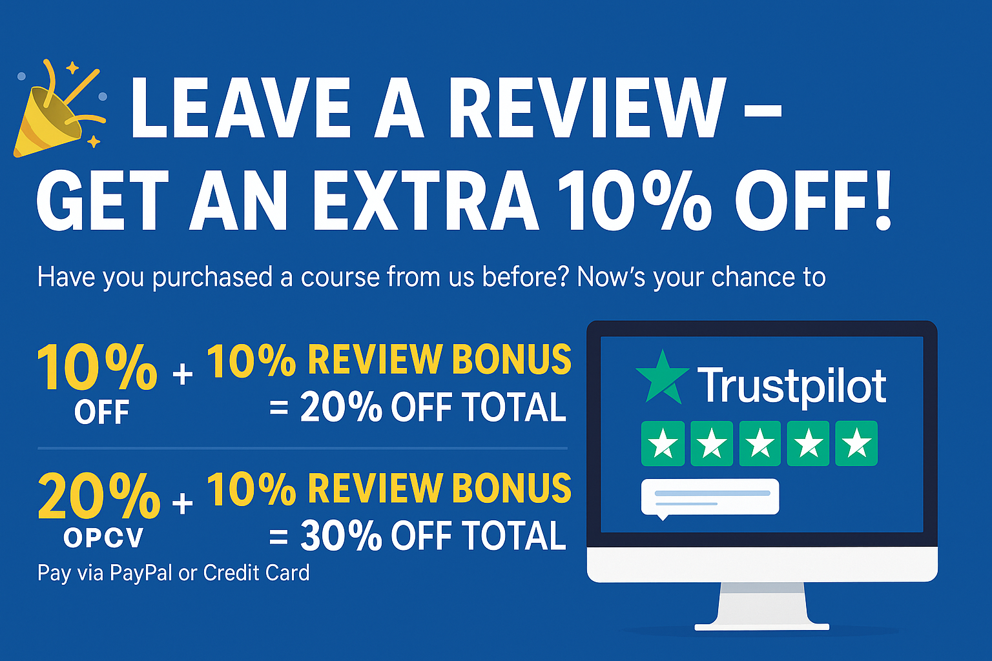

🛎 Note:
This course was downloaded and verified by the Amanda Team.
Buy directly from us [https://course24h.com/] to ensure the best experience and access to future updates.
Thanks again for your support! 💙

