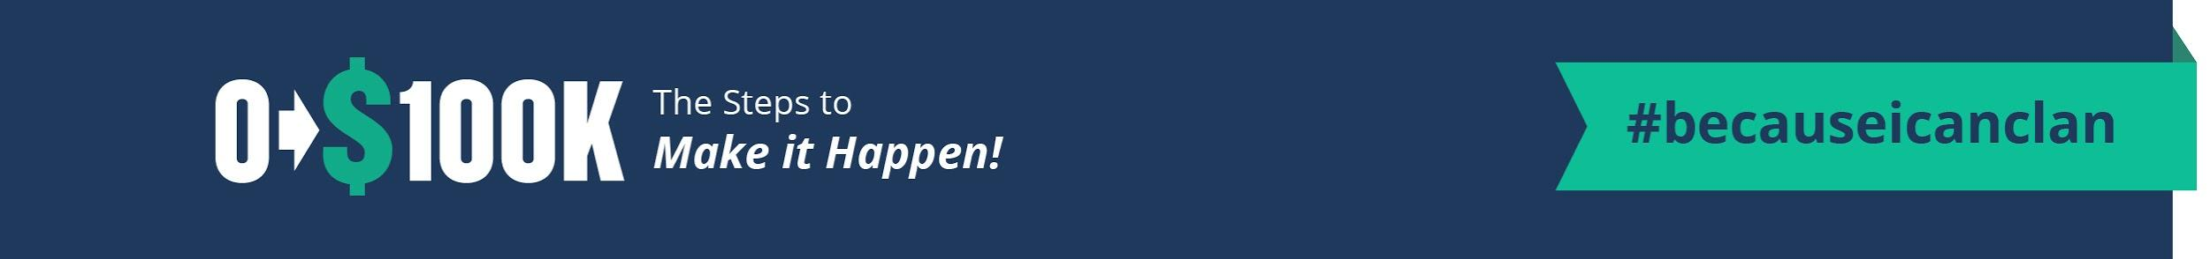
FAQ for the 0-$100K System

Stuck? We are here to help.
Note: If you hit ‘Control+F’ a ‘finder’ will pop up and you can put
your keyword in there and it will get you to your answers faster.

How much will it cost (besides the program) to get up and running?
That is a great question!
First, You need your EIN. That is free. I have a link in the 0-100K System for you to get that.
You’ll need a business license and that depends on what State and City you live in. This is required for all businesses. It’s a government thing. I’ve seen as low as $200 and as high as $800 (California is one of the highest).

Second, I recommend only investing $100-$200 to start testing your products. If they sell well, then you’ll have more money to buy more products. Please don’t invest $1,000’s of dollars into this at first. Sell and get money rolling in.

Third, is shipstation and that is around $30 a month. You don’t have to have this at first, but you’ll want it once you hit around 20-30 orders. It will start paying for itself because it will save you money in shipping costs and time. You can start with as little as what is mentioned above. As soon as sales are made then you can upgrade to bigger and better to help you streamline the process and to make it easier and make more sales.

Fourth, Shipping products. DON’T BUY a lot. Get them from Amazon for the cheapest. As you get cash flowing you can buy branded packaging.

Fifth, I want you to get cash rolling in to help you pay for your own shop.

How long until we can make money?
I’ve seen people make money in as little as 1 week to 4 weeks. If you already have an LLC, you can launch faster. The government has these rules we have to follow and sometimes that can push things back a week or so.
If you don’t have an LLC, the government requires that and it’s an extra step, but you need to get that done. Watch Module 2 Fast Track to Cash so you can see how you can get products in fast before the black book is opened up to you. You can start setting up your account on some deal sites with only your EIN. You’ll need to have your LLC before you start selling, but you can get pictures, pricing, and your text in while you are waiting for your LLC to arrive. My goal is for you to make back the cost of the course in 4-6 weeks. Is that a guarantee? No. Why? I don’t know how fast you are going. I’d love for everyone to hit that, but I know some people who want to go slower and that’s okay. This is a work at your own pace program...although I’ll push you:) Check out some people who've made this happen

How do create a brand if I don’t know yet what I want to sell?
Check out Module 2. It’s a great way to learn what product you want to sell. Check out the trending product section too. Remember you don’t need a shark tank idea (lesson 5.1). Just sell what others are selling. Once you've found what sticks, then build your brand around it.

Do I need an LLC for each site or product?
Depends. Check the FAQ in Module 1 for more details.

Do I need to pay someone to be my registered agent or is it ok to be my own registered agent?
Check the FAQ in Module 1 for more details.

I want to create xxx(something with fabric):
Check the little black book of manufactures (USA version). There is a list in there of sewing contractors you can contact.

Where can I find wholesale fabric:
Check the little black book of manufactures (USA version). It's at the very top!

I need some Wholesale decor WHOLESALE ideas/places:
Check in the little black book of manufactures (USA version). There is a list in there!

Where do you find wood products?
Check the little black book of manufactures (USA version).

Do you have any companies that do personalization?
Check the little black book of manufactures (USA version). There is one in there.

What is BYB? BrickYardBuffalo.com SS? Sassysteals.com

Will this work in xx country:
People need products and you want to be the one to sell it to them. I do discuss deal sites here in the USA, but skip that part and go for the branding and building up a company. That is the real goal.

14 day guarantee- Can I Have The Little Black Books Early?
The reason for the 14 days is because of the little black book of manufacturers and the blogger's book. Over the last 7 years I have poured blood sweat tears and a lot of money into finding the best people to work with to build businesses. I've had people come into the course take the black book and then ask for a refund. Honestly, it hurt my heart. On the flip end, people who are in the course want this info quicker than 30 days so I've found 14 days seems to be the perfect fit.

Starting in 4th quarter. Any tips?
Great question. Everything is still the same, but don't do pre-sales. The reason is because vendors sell out so quickly and it can get frustrating very quickly. I would order the smallest amount possible. Buy the smallest you can, test it out and roll that money that you make into more quantity and repeat the process. Here is a free pdf that goes into more details about how to line up cyber sales to be successful.

I’m afraid that a product is saturated.
Check out 5.1 on how you don't need a shark tank idea. I put this in the faq section under the training video.

Can I use other people pictures?
Only if you ask! Make sure to get written permission. Stealing pictures is not a cool game to play.

What is epacket?
It’s a China shipping service. It’s not bad, but the shipping time is all over the place. I’ve gotten stuff in 2 weeks and as long as 3 months. I like to go with dhl for a better shipping time. I always check for free shipping too. Check out lesson 0.6 for more details.

Who does your t-shirts?
Whitney at BWDesigns.com.

What in the Devil is a SKU??
The only place I’ve needed real SKU’s is on Amazon and I don’t sell very much over there. I just wanted to see what it was like, and I didn’t like it as much. I honestly just make up sku’s for deal sites. They are there to help you, the business owner to keep things in order and for fancy pancy systems. When deal sites ask me for sku’s, I just make them up. So if it’s a unicorn pillowcase. I’ll put UNIPILL. That way when I see the sku, I know what it is. Keep it simple. When you become the next Amazon, you’ll see why sku’s are important, but that might be a few years before you reach that;)

How do you sell on Amazon?
Well, I don't know. This system is working on building your brand off Amazon for you to get higher margins and grow your own list and create your own traffic. This is how I've grown all of my e-com businesses. It's a magical world out there without Amazon.

How do you find products you don’t have to worry about patent infringements?
Check out 5.1 FAQ. I try to avoid this! I'll give you links and tell you how to avoid this.

What about Trademarks?
5.1 under the video. I’ll show you the link to find out how to know.

Who does your t-shirts?
Whitney at http://www.bwgraphics.com/
Alice uploaded this screenshot of some great ones too.
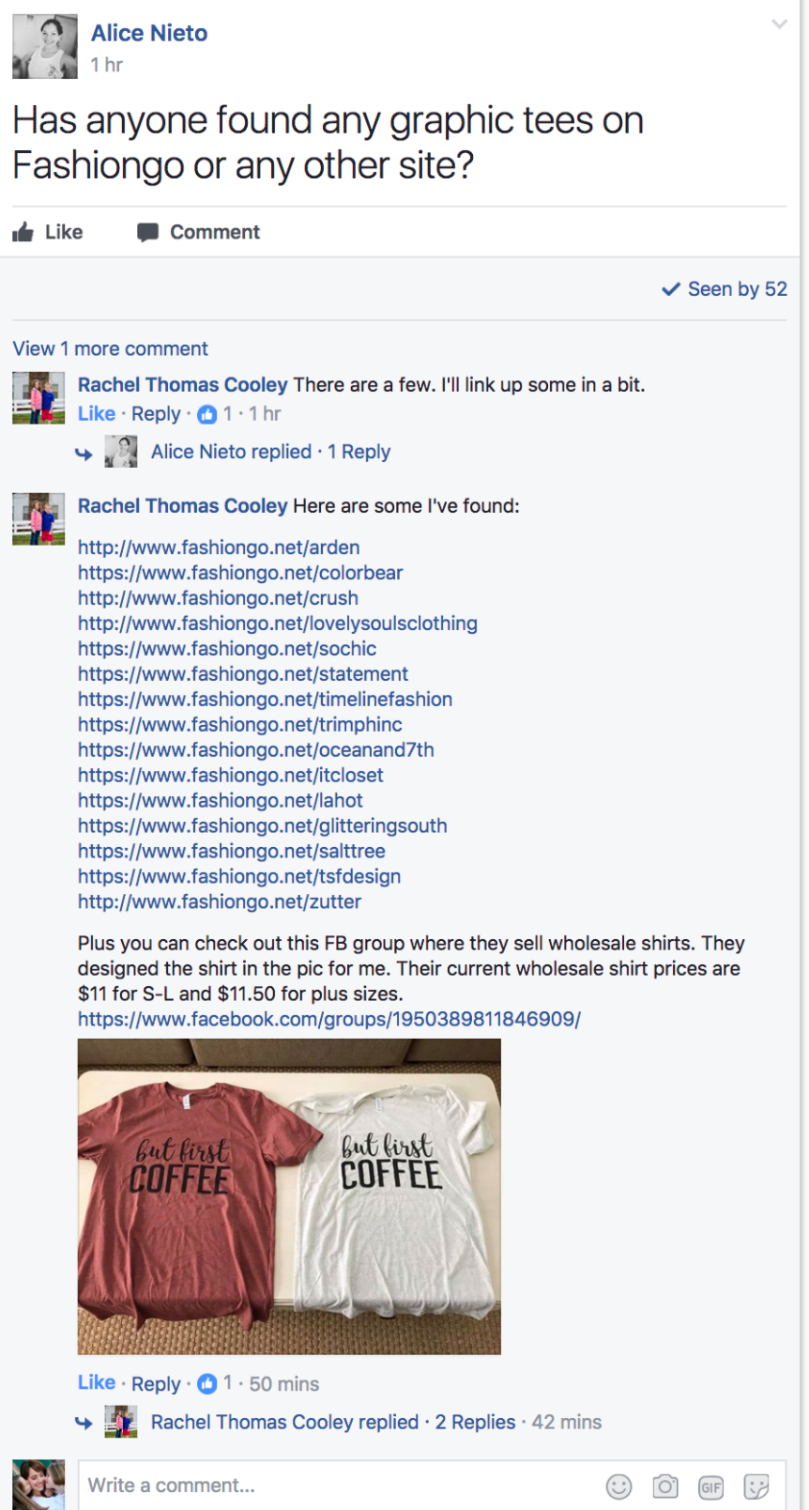

Do you have a good way to calculate margins?
Yes! So glad you asked. In Section 6 (pricing your products), the first section has the profit calculators. This is so dang fun for me...calculating profits = happiness.

What are item components on the margins doc?
Anything extra. ‘Free earrings’, laffy taffy, etc.

What is presale?
Check out 13.4 Trash to Cash

Can we sell before we buy?
Check out 13.4 Trash to Cash

What if I’m stuck. What am I missing?
Keep trying. Use the products you currently have and switch it up. New pricing, New pictures, New Copy. Remember not to invest a lot in product and don’t just randomly choose cute stuff. Have you see the what to do with cat hair book on amazon? I’m sure the author though it was cute too. Rewatch the trending video. 5.1 and 5.2
​Check this tutorial out too

How do I sell more on deal sites?
How Do I get featured on a Deal Site? 9.4 goes into more detail Ask for a higher listing? Great Pricing Lesson 6 Great Products Lesson 5 Great Pictures Lesson 8 Great Copy 11.2.
Here's a great tutorial on ways to swap things up too. https://youtu.be/RIzB5DOnH6c

Can you go over pricing for deal sites and realistic profit margin expectations? Some of the deals I’ve seen don’t seem to very profitable unless they’re sourced direct from manufacturer. Any suggestions for how newbies like me can compete?
Check out 9.4 FAQ.
Wait, What do you do again? Where do I start?
Watch 0.0-0.4

Can you submit to 3 deal sites and get accepted by 2 and just make sure they are not going to run at the same time? Yes.

Are there manufacturers who will put your design on their products for you?
Yup, that’s what the little black book of manufactures are for. China edition. They make everything and anything you want.

Can you explain after you find a product that sells really well from fashiongo, how to find that same product cheaper from China? Do you show the manufacturer a picture of the item and they replicate it?
Yup, but I’d only do that on clothing if you are selling tons. The MOQ on ordering clothing is high. Also, give it a bit of twist so you are not exact copying. I’ve sent plenty of pictures to China of items I want and then change them (to something that I would want better) to avoid copyright. Add pockets or a different neckline cut. Different type of fabric, etc.
What is MOQ?
Minimum Order Quantity. What the minimum quantity you have to order from a manufacture.
.
Where can I look to find a better grasp on clickfunnels?
9.3 in the module or on the clickfunnels website. Clickfunnels is best for one product. NOT a shop of products. Fabric, I sold white with black print. That was it.

What do I use for a crm?
I use Shopify to keep track of everything in those shops. There are also more apps shopify for that if you want to go deeper. Search in the apps section in your shopify store and you’ll find the one that works best for your style.

What is a CRM? Customer Relationship Management - allows businesses to manage data and information associated with them

What is a good price for a website to sell products? $30/mo on shopify

Whats a good price for a URL? If it’s not taken by someone, it will only be $20 ish. Opt for the privacy option or you will get spammed. That’t the only 2 things you should buy from go daddy. The domain and the privacy option.
Use godaddy.com for your domain (URL).
Use shopify or Clickfunnels for your website. Do NOT buy a WEBSITE from godaddy.
Use gsuite for your emails.

What is a good price for a logo? Check out 3.2 FAQ

How and where to look for next quarters trends?
Check out 5.1 and I show you some insider tips.

How do I get Great Pictures with Zero Budget? Check out 8.1 and get some awesome tips over there. I tell you how I started with PYP.

Is it better to have items that sell for higher prices $19-29 or for lower $5-10? Doesn’t matter. It’s all in the value that you are offering. Check 6.3 in the course to find sweet spots.

I found a product I like, but shipping looks like it will eat up my profit margin! Use shipstation to find you the best rates. Charge more for the product. Add value.

The best automated abandoned cart app for Shopify. If you integrate with mailchimp, they offer a great option and mailchimp is free for the first 2000 customers.

I was wondering if Jared works with you full-time? No, I fired him. I love him way too much for business to be the center of every single topic. Does he help me when I get in a bind? YES! Does he know all the ins and outs? Yes, it’s because I’ve talked to him about business for 8 years. Besides, his passion is healing people in physical therapy which he’s put on hold to help raise the kiddos. Working on letting him live his dream again.

How do I work less? (Lesson 14.1) HIRE IT OUT! You should only be building, selling and branding your products. In the beginning you’ll be wearing every single hat, but as soon as you can let someone wear one of that hats DO IT!

Who is your shipping broker? Check the bonus section. I interview my broker, give you his name and email. YEAH!
When will I need to use a shipping broker? Feel free to contact a shipping broker at any time. Most are more than happy to help. According to Mike (contact above), if it’s shipped by boat you need a shipping broker for sure. Air shipment will depend on product and amount. Anything over $1000 reach out to a shipping broker.

Has anyone here had a custom design made through a manufacturer on alibaba? I asked for sample quotes and she would like to see the design which is understandable. Is there any assurance that my design won’t be made available to everyone else as well? Any advice appreciated.
The only way to protect your design is #1. Get a lawyer involved. They can help protect it correctly and show you how to follow up with people who knock you off. #2. This is not a guarantee, but it worked with me. I built a great relationship with my manufacturers and they said they wouldn't sell my designs. They could be lying(heck, they are on the other side of the world:), but I honestly trusted them.

Is payment via western union a good idea? NOOOOOOOOOOOOOOOOOOOOOOOPE Never ever. Use paypal or their inhouse site until you learn to trust them. Then you can wire the money, but never use Western Union. EVER.

Taxes. If you have specific questions or are confused, please reach out to an accountant.
#1 - Most deal sites only collect sales taxes for the state they are in. For example, Jane only collect sales taxes for Utah. You will have to check with individual deal sites to see their policies.
#2 - If your state requires it, and most probably do, you will need to pay sales taxes on your own for any purchases by customers in your state. This is because you have a sales nexus in your state due to the fact that you are running the business and shipping out products from that state. If you have an employee in another state who also ships out, or you drop ship from a company in another state, you might have to pay taxes for that state as well.
#3 - Since the deal sites don't collect sales taxes for your state, that amount will come out of your sales margins. Keep that in mind when pricing.
#4 - In some states (I know Texas is one of them) you have to pay sales taxes on the total amount you collected from the customer. This means the order total (item cost + shipping collected). You need to check your individual state guidelines.
#4 - For getting sales information, ShipStation allows you to pull a report for your completed orders that gives you the line item order information. (Shipped > Stores > Select the Store > Other Actions > Export Orders). This gives you a line item report of orders so you can filter them by your state. For Sassy Steals and Jane, it shows the total of the order (item + shipping collected).
#5 - You have to talk to an accountant or do research on what sales tax % you need to pay. Some states charge sales tax based on the origin of where the item is sold/shipped from, and others charge based on the rate at the destination city the package is going to.
More info can be found here: https://blog.taxjar.com/charging-sales-tax-rates/
#6 - For those in Utah, the site to pay your sales tax: https://tap.tax.utah.gov/taxexpress/_/

What is the real secret to success? The secret is testing it, tweaking it and trying it again and building a brand. That really is the secret.

What if I want to open my shop and I don’t have a huge inventory?
Don’t stress it.
Shopify has some themes built around smaller inventory. I actually really like these. You’ll notice my pillows are their own site. Not pillows, jewelry, and socks. One thing. Buyers get overwhelmed and walk away. See below for the templates shopify offers.
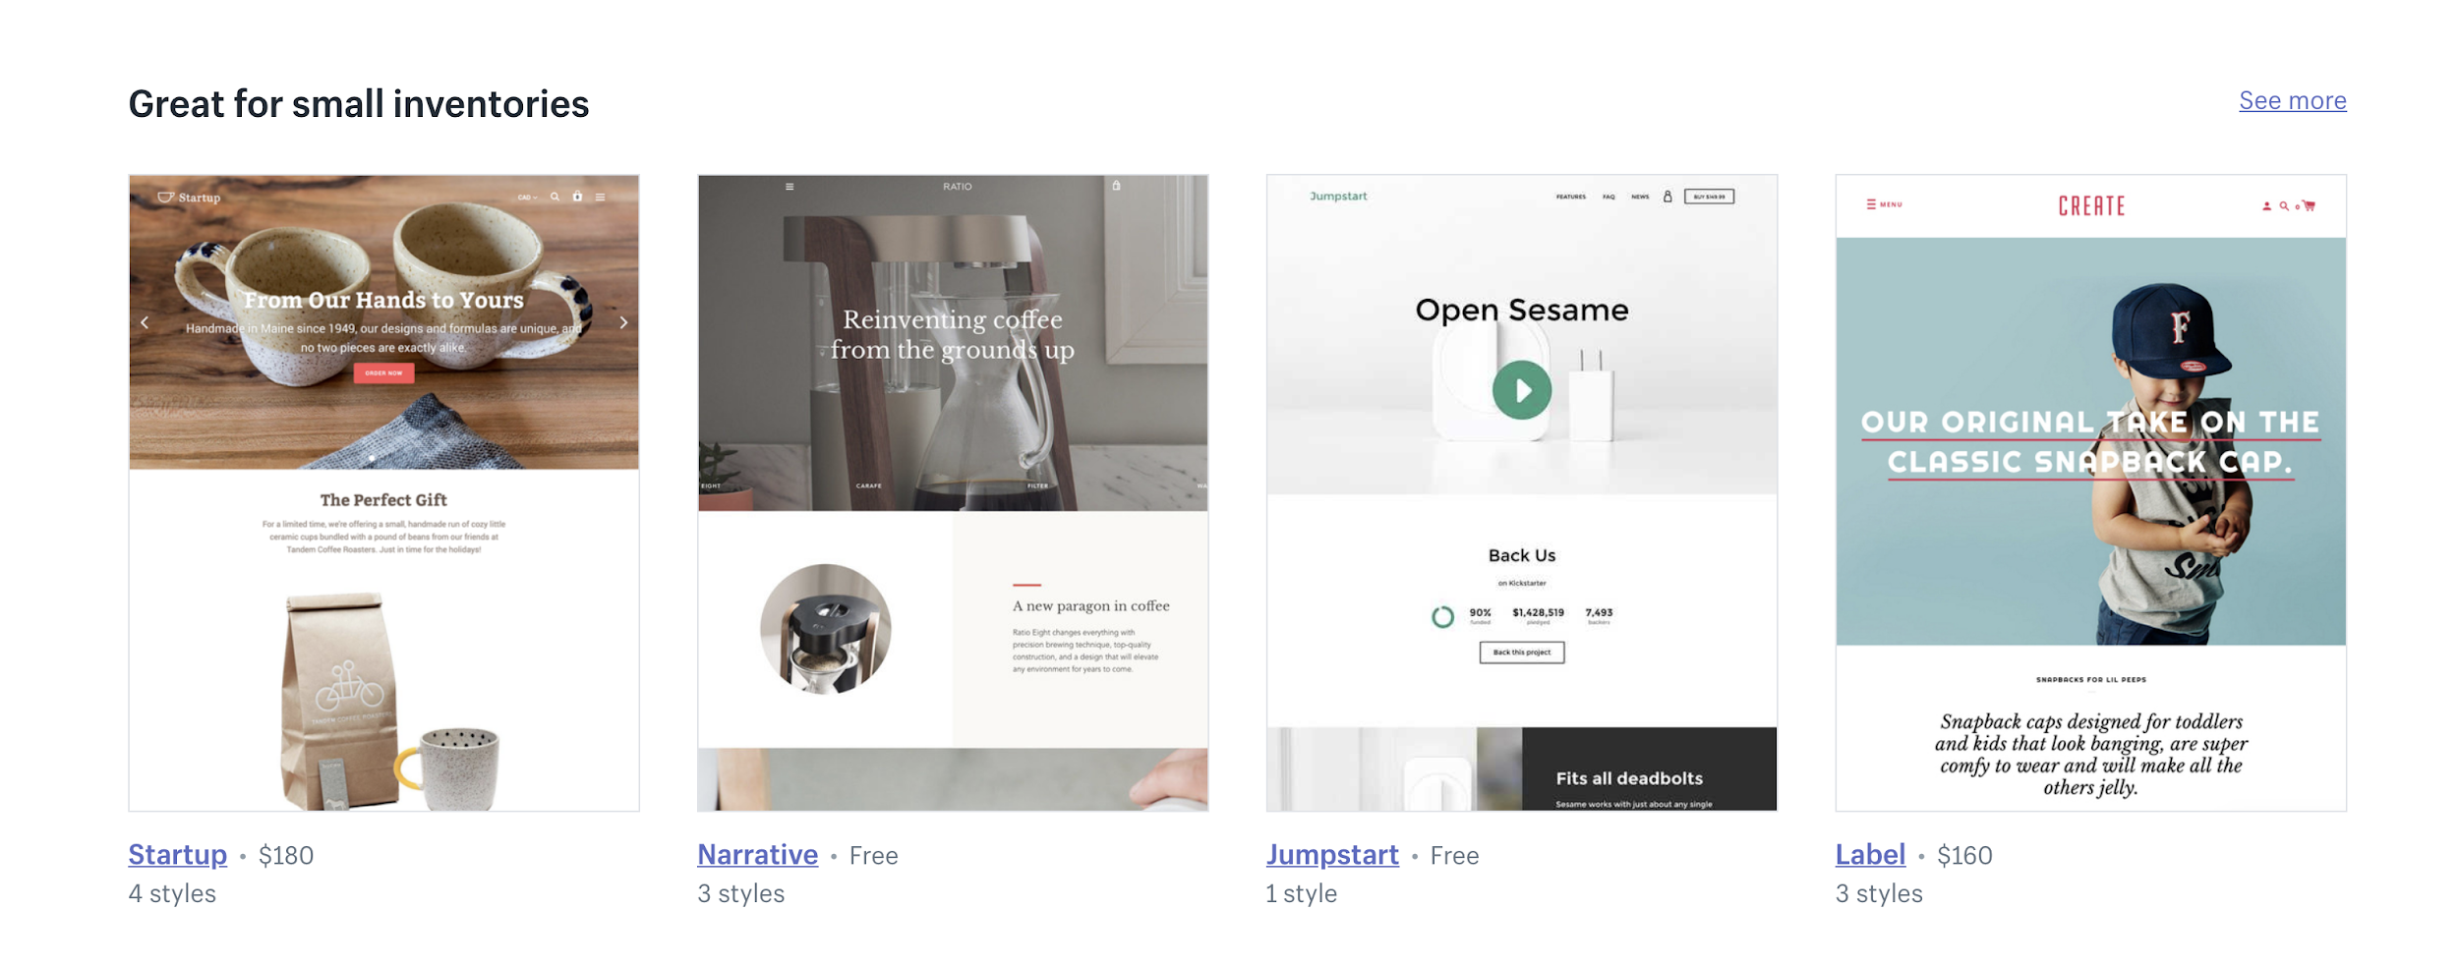

I’m thinking about cosmetics or lotions. Where should I start?
I would start with white label companies. Test your results and the market first. I have not sold lotions or potions before, but here are a few that I’d look into.

Here are some white label companies.
https://brushesbykaren.com/
https://www.qualitycosmetics.com/
http://www.pinnaclecosmetics.com/
http://www.voxskincare.com/

Do I need insurance?
Legally, I need to say yes.
You can get it for pretty cheap. Your insurance company can help you get the right coverage. Everyone's will be a bit different due to the products they are selling. Note: They will not cover any products with lead in them. You don't want to sell that stuff anyway!

I started without it because I didn't know it existed and by the time I found out that I needed it I had cash coming in.

Organic Vendors in the USA
https://www.royalapparel.net/wholesale

Deal Sites in Australia
http://mumgo.com.au/
http://groupon.com.au/
http://dealsdirect.com.au/
http://zulilly.com.au/
http://fashionlane.com.au/
http://ourdeal.com.au/
http://retailmenot.com.au/

Dropshipping
I came in planning to drop ship and now it seems that's not too smart due to quality, etc. So I'm reworking my concept to build a brand and one thing I'm struggling with is all the extra costs w/ storage, shipping materials, labor, time, etc. Profit margin is very small when all expenses are totaled and it's a huge time investment as well. Not sure where to go with this. I was hoping to create a side business that didn't take too much time and could bring in a few extra $k per month, eventually. I already have a brick and mortar (service biz) and was hoping to move away from that. What are you guys doing to make it work? How much profit should be expected (on a % basis) to be considered a win? I know there's lots of talk about $ sold, but what are the actual $ profits after all the time and hard costs (including employees, etc.). I need direction to actually find a product that will work for me, considering the above. I'm guessing you need a higher end product to make it all work?

You can do dropshipping....don't stop because of the smaller margins. In business building, you have two things. Time or money. If you don't have a lot of time to get it up and going, then the dropshipping margins are better than none. If you want to do your own thing, then look into a shipping company. Shipzoom will pick, pack, and get things out the door and you'll never have to touch products or orders. Your margins will be a lot higher than dropshipping too. When I first started, I hired my neighbors to ship for me. They were grateful for the work and I was grateful I didn't have to ship. They did it all for me. I agree...get shipping off your plate asap and focus on marketing your product. You want to be getting 30% if you are using vendors (middle men). You can get a lot higher when you go to china. My girls bought their scarves in Cali for $3.50 and got them in China for $0.57. They sold a set of 3 for $13.00 + free shipping. Their margins when sky high when they moved to a manufacturer. Test the market, make sales, then talk to manufacturers.
Higher priced products, you don’t need to do that. I sold products for $2.99 and made it work. I sold a lot of them, but it works when your margins are right.

How do you make a white background?
https://fotofuze.com/ offers a free service to remove the background.

Where do I get the tattoos I send out?
24hour wristband at this time.

What about the branded #clandrop tape:
Tape Jungle - It does take a long time. In the future I’ll get it from China, but wanted to see the reaction first before I put it a ton of money on tape.

Stickers?
Print Runner. I’ll get them from china in the future. Again, just testing with products I can get fast here in the USA. Once I nail my branding for the #clandrops, then I’ll take it to China.

Boxes?
Packlane or Print Runner are in the states.

How do you get traffic?
Section 13 is your goldmine!

This is one of the most asked random question so I figured I’d address it here.
Lipstick and Mascara.

Mascara:
I get it at walgreens or amazon

Lipstick:
#1 NARS American Woman
OR
#2 Sephora #13 Cream Lip Stain

Then I top it off with Buxom Pink Champagne

Recommendations from Other Clanners (but I have not used them):

Web design, business cards, logos, video editing: http://www.thediamondentity.com

VA Services: http://www.socialboat.org/ marjorie@socialboat.org

Messenger Bot Services: Emily Bass emruth122@gmail.com

Sign Up Form for Clan Seat Facebook Lives
https://goo.gl/forms/yflXW6cg8Da5LUTj2

Application to be admitted to the #10GrandClan when you reach $10K in sales!
https://goo.gl/forms/apvobAyWyGlXtbG02

Application for #50GrandClan!
https://goo.gl/forms/hi6qFk249Qey74R93

Application for #100GrandClan!
https://goo.gl/forms/dYnvSr02RRPzqAz82

