Let’s Do This.
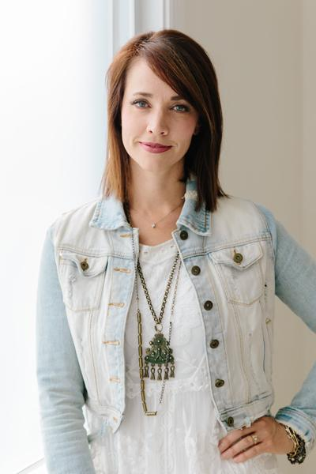
First, Define Your Brand.
Replace my mug with a picture of your mug. This is about you and how YOU CAN DO THIS!
Copyright 2017 @AlisonJPrince, LLC
Don't Steal. Don't Copy. Karma is Real. She's a Beast.
I’ve put years into figuring out what works and what doesn’t. I share both. I’m pretty dang open AND I want to keep doing that for you...so don’t share, copy, steal. This is for personal use only. Got it? Good. Now let's get to work.

What DRIVES you?
What is the motivation behind this dream that you’re pursuing?
(Your answers here)

Define Your PERFECT Customer.
- Male, female or both?
- How old are they?
- How much money do they make?
- Are they single or married?
- Where do they work (or do they work?)
- What do they do in their spare time?
- What do they think about?
- Do they have kids? How many?
You’ve done the work defining your perfect customer, now give them a name. This is who you will be selling to.
Example: Female, named Nikki with four kids. She is 34 years old and married to a good man. She is able to stay at home mom. They bring home around $70k a year. Nikki likes to focus on her family but loves a good night out at target (alone). She wants to make her life purposeful to her family and others, she’s always trying to look good but not spend a ton of time on it. She’s usually in a hurry, but likes to do thoughtful things for friends and family.

My perfect customer is…
(Your answers here)

What

Inspires You?

- What colors tickle your fancy?
- What fonts do you crave?

I am inspired by…
(Your answers here)

What Makes YOU Unique?
Not the product… YOU.
Example: I’m thrifty, but like high quality. I want to spoil loved ones around me and make them feel special. I like to build businesses and make money. Finding out what made me unique helped me to build pickyourplum. I built a business around savings and high quality products. I’m able to give random products to friends and family. It’s also a business that has made me money and that’s fun. Note: Notice how this has nothing to do with the product. It has to do with who I am. This will fit into my lifestyle and help me to reach my goals faster. This is me.

These are some things that make ME unique…
(Your answers here)

